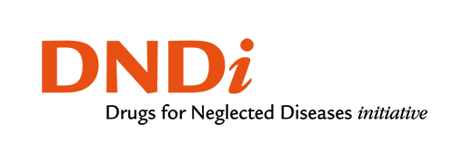

User Guide for the Visceral Leishmaniasis annotated Case Report Form (aCRF)

Version final draft

Prepared by the
Visceral Leishmaniasis (VL) aCRF Team

Notes to Readers
- This is a draft version of the User Guide for the VL aCRF.
- This document is based on CDASH v1.1 and CDASHUG v1.0, SDTM v1.7 and SDTMIG v3.3.

Revision History
Date | Version
2021-03-31 | 1.0

CONTENTS
User Guide for the Visceral Leishmaniasis annotated Case Report Form (aCRF) 1
Version final draft 1
CONTENTS 2
Tables 3
Figures 3
1 Introduction 4
1.1 Existing CDISC Standards 4
1.2 New CDISC domains 5
1.3 Organization of this Document 6
1.4 Known Issues 7
1.5 Overview 8
2 Timing Considerations 13
3 Subject and Disease Characteristics 14
3.1 Inclusion/Exclusion Criteria 14
3.2 Demographics 14
3.3 Baseline Assessments 15
3.3.1 Medical History and Symptoms 15
3.3.2 Prior and Concomitant Medications 15
4 Disease Assessments 16
4.1 Visceral leishmaniasis Symptoms 17
4.2 VL Diagnosis 17
4.3 VL Efficacy Outcomes 22
5 Routinely Collected Data 23
5.1 Site and Trial Level Data 23
5.2 Anti-leishmanial Treatment Administration 24
5.2.1 Combination Therapy 24
5.2.2 Post Dose Vomiting 24
5.3 Laboratory Tests of Special Interest 25
5.4 Safety Monitoring 26
5.5 Adverse Events of Special Interest 26
5.6 Pharmacokinetics 28
6 Analysis Considerations 29
6.1 Subject Level Analysis Data 29
6.2 Analysis of Efficacy Outcome 30
6.2.1 Efficacy Outcomes 30
6.2.2 Efficacy Outcome Analysis Results 31
6.3 Analysis of Temperature Data 31
6.4 Analysis of Haematological Data 31
6.4.1 Haemoglobin Data Analysis Results 32
6.4.2 Spleen Size Analysis 32
7 Appendices 32
7.1 Project Team 32
7.2 Project Collaborators 33
7.3 Glossary and Abbreviations 34
Sodium stibogluconate (SSG) & paromomycin 35
7.4 Non-Standard Variables 35
7.5 References 36

Tables
Table 1 | Grading and description of PKDL

Figures
Figure 1 | Biology. Centers for Disease Control and Prevention. http://www.cdc.gov/visceral leishmaniasis/about/biology/. Published March 1, 2016. Accessed June 20, 2020.
Figure 2 | WHO: Status of endemicity of visceral leishmaniasis worldwide, 2018. https://www.who.int/leishmaniasis/burden/GHO_VL_2018.pdf. Accessed October 25, 2020
Figure 3 | Schematic representation of the diagnosis of visceral leishmaniasis
Figure 4 | Schematic representation of treatment response from Day1 through follow-up

Introduction
This user guide for visceral leishmaniasis (DSUG-VL) was developed by the Drugs for Neglected Diseases initiative (DNDi), the Infectious Diseases Data Observatory (IDDO) and relevant interested research partners, including input from the Clinical Data Interchange Standards Consortium (CDISC), the World Health Organization (WHO), Médecins Sans Frontières (MSF), regulatory authorities including the U.S. Food and Drug Administration (FDA) and the European Medicines Agency (EMA), VL experts from the major endemic regions of Brazil, East Africa and South Asia, academic institutions and pharmaceutical companies including Novartis and GlaxoSmithKline (for a full list of partner institutions, please see Appendices section 7.2). It focuses on clinical trials in patients with visceral leishmaniasis (VL). However, some sections may be relevant to other types of leishmaniasis such as cutaneous and mucosal; and patients with Leishmania-HIV co-infection. In addition, sections may be relevant to other research studies such as diagnostic studies and routine surveillance monitoring.

The development of this user guide followed a process similar to that used in CDISC Therapeutic Areas User Guides (TAUGs) such as the TAUG-Malaria. This process included collecting resources, such as Case Record Forms (CRFs), study protocols and study data from various stakeholders to ensure the user guide is as comprehensive as possible. Many diverse researchers and experts provided such resources and other input to support the development of this user guide. The goal of this user guide is to specify a core set of clinical therapeutic area concepts and endpoints for targeted therapeutic areas and translate them into CDISC standards to improve understanding of data and metadata concepts, support data sharing and facilitate regulatory submission. While this user guide mimics the structure of a CDISC TAUG, it has not gone through the CDISC Standards Development Process and is not a CDISC product. If guidance in this document conflicts with published CDISC standards, the published CDISC standard supersedes the guidance in this document.

Existing CDISC Standards
- This document is based on CDISC standards and principles, including from the following formal CDISC references:
CDASH [Model 1.1]
CDASHIG [version 2.1]
SDTM [version 1.7]
SDTMIG [version 3.3]
- This document is not, and does not try to be, an exhaustive documentation of every possible kind of data that could be collected in relation to VL. The team does not intend to describe what every possible kind of data that could be collected in relation to VL might be, especially because research is always evolving. They have tried to focus on those areas that the team's resources have identified as most likely to be relevant and useful more often than not.
- The advice and examples presented in this document are influenced by ongoing internal standards development at CDISC cited above. If a modeling approach seems inconsistent with a published standard, it may be a genuine error, but it could also be a reflection of potential or upcoming changes to the standard.
- The examples in this document use CDISC controlled terminology where possible, but some values that seem to be controlled terminology may still be under development at the time of publication, or even especially plausible "best guess" placeholder values. Do not rely on any source other than the CDISC value set in the NCI Thesaurus (available at http://www.cancer.gov/research/resources/terminology/cdisc) for controlled terminology.
- As this document ages, parts of it may become outdated. Those parts will be updated in the next version.

New CDISC domains
In instances where a standard domain within the CDISC SDTM has not been defined, a custom domain may be created after first ensuring that this has not already been defined in one of the other CDISC Therapeutic Areas User Guides (TAUG). Such a domain would need to sit in one of the four main types of domain: special purpose, relationships, trial design and general observation classes, of which the general observations classes covers the majority. The general observation class has three main general classes: the Interventions class, the Events class and the Findings class, which covers observations resulting from planned assessments such as audiometry to evaluate a subject’s ability to hear sounds. As hearing loss in VL is a known side effect of one of the treatments that are standard of care in some regions (see section 5.4 Ototoxicity), after ensuring that this data could not be mapped to an existing standard domain, a new domain is proposed. The following steps need to be followed:
- Determine which of the three general observation classes is the best fit for the new domain (in this instance the proposed domain is the findings domain.
- Determine a two-letter domain code which is different to any currently published (in this instance AU is proposed).
  - Include the mandatory identifier variables (STUDYID, DOMAIN, USUBJID and –SEQ)
  - Include the topic variable for the findings class (in this instance TESTCD)
  - If necessary, include relevant qualifier variables from the identified general observation class, which is well defined in sections 2.2.1, 2.2.2 and 2.2.3 of the STDMIG.
  - Include the order of the variables, identifiers followed by first topic variables, then qualifiers and lastly timing variables.

It is important to note that the inclusion or exclusion of concepts in this user guide has nothing to do with whether such concepts may, should, must, must not, should not, or need not be collected in any given VL trial. This user guide is not intended to tell you what data to collect or how to run your trial or treat your patients.

Organization of this Document
This document is divided into the following sections:
- Section 1, Introduction, provides an overall introduction to the purpose and goals of the VL aCRF project and this accompanying user guide.
- Section 2, Timing Considerations, shows how the conventional time points in VL research, the SDTM Study Days, and protocol defined windowing are related in this guide.
- Section 3, Subject and Disease Characteristics, provides a brief introduction to VL, and covers data that are usually collected once at the beginning of a study.
- Section 4, Disease Assessments, covers data that are used to evaluate disease severity, improvement, or disease progression. These are usually collected repeatedly during a study, and may be used as, or for, the derivation of efficacy and/or safety endpoints.
- Section 5, Routinely Collected Data, covers repeatedly collected data not related to disease assessments, such as concomitant medications and adverse events. Only aspects of these data that are not covered by existing standards are discussed.
- Section 6, Analysis Considerations, includes analysis considerations for VL studies.
- Appendices provide additional background material and describe other supplementary material relevant to visceral leishmaniasis.

Known Issues
- Collection of age versus date of birth: to comply with local and national regulatory requirements and data privacy laws Date of Birth might not be an allowed option to collect, in some instances it might be considered reasonable to collect only year of birth; if not, age and the units of age (such as years, months, weeks) will be collected.
- Collection of ethnicity and race: if the data will be submitted to the U.S. Food and Drug Administrations (FDA) for possible registration, it is essential that both race and ethnicity are represented at the individual patient level.
For ethnicity the FDA recommends the following minimum options be offered:
- Hispanic or Latino: “A person of Cuban, Mexican, Puerto Rican, South or Central American, or other Spanish culture or origin, regardless of race. The term, “Spanish origin,” can be used in addition to “Hispanic or Latino.”
- Not Hispanic or Latino
For race the FDA recommends the following minimum options be offered:
- American Indian or Alaska Native: A person having origins in any of the original peoples of North and South America (including Central America), and who maintains tribal affiliation or community attachment.
- Asian: A person having origins in any of the original peoples of the Far East, Southeast Asia, or the Indian subcontinent, including, for example, Cambodia, China, India, Japan, Korea, Malaysia, Pakistan, the Philippine Islands, Thailand, and Vietnam.
- Black or African American: A person having origins in any of the black racial groups of Africa. Terms such as “Haitian” or “Negro” can be used in addition to “Black or African American.”
- Native Hawaiian or Other Pacific Islander: A person having origins in any of the original peoples of Hawaii, Guam, Samoa, or other Pacific Islands.
- White: A person having origins in any of the original peoples of Europe, the Middle East, or North Africa[1].
Data on ethnicity and race should also be adapted to the local requirements and regional context of VL in patient populations in Asia, Eastern Africa and Latin America.

Overview

Leishmaniasis is a parasitic disease caused by infection with Leishmania parasites, which are transmitted by the bite of the phlebotomine sand-fly and is classified as a Neglected Tropical Disease (NTD)[2]. There are three main forms of leishmaniasis: cutaneous leishmaniasis, which causes skin sores, visceral leishmaniasis (also known as kala-azar (KA), a Hindi term meaning ‘black fever’), which affects several internal organs (usually spleen, liver, and bone marrow), is characterized by irregular bouts of fever, substantial weight loss, swelling of the spleen and liver, and anaemia (which may be severe) and mucocutaneous, which affects the mucous membrane of the nose, mouth and throat.
Infection can be caused by more than 20 Leishmaniasis parasite species which are transmitted by about 30 phlebotomine sandflies; certain species of parasite are spread by certain species of sandflies in the different geographical regions. The sandflies are most active from dusk to dawn.
The two VL species are L. donovani, in South Asia and Eastern Africa, and L infantum, in Latin America and Mediterranean regions. L. donovani is considered an anthroponotic species, mostly infecting humans (although some animal reservoirs have been described in Africa), whereas L. infantum is a zoonosis, with dogs as main reservoirs of the disease. A large proportion of people infected by the parasite do not develop any symptoms at all in their life. Therefore, the term leishmaniasis refers to the fact of becoming sick due to a Leishmania infection and not the mere fact of being infected with the parasite.
The most typical VL symptoms are fever for longer than 2 weeks and the enlargement of the spleen (possibly enlargement of the liver as well), substantial weight loss and anaemia. Presenting symptoms are similar to malaria, so in co-endemic areas, this is an important differential diagnosis to consider. If untreated, severe (advanced) cases of VL typically are fatal.
VL is endemic in more than 60 countries, with over 90% of new cases reported to WHO from Bangladesh, Brazil, Ethiopia, India, Kenya, Somalia, South Sudan and Sudan.[3] Across regions VL remains a disease of poverty promoted by poor housing and other conditions supportive to the disease vector, such as overcrowding, proximity to animals and remote areas with limited health care facilities.

Post-kala-azar dermal leishmaniasis (PKDL)
PKDL is a known complication of VL caused by L. donovani. In the large majority of cases, dermal lesions develop a few months to several months after the clinical cure of VL, but sometimes PKDL may manifest concomitantly with VL (para-kala-azar dermal leishmaniasis). However, cases have been reported in the literature in the absence of a history of VL. In Eastern Africa, PKDL is mainly observed in Sudan, where about 55% of successfully treated VL patients develop PKDL within 6 months of VL treatment. The lesions are typically papular (although macular and nodular forms may also occur), starting in the face, and progressively expanding to the trunk, limbs, hands and feet. In Africa, the distribution and density of lesions is used for a classification system (see table 1 below). In Asia, 5-10% of the patients develop PKDL, with median time of 24 months after VL treatment. The most common clinical manifestation in Asia is the macular form, but some patients can also present nodular and papular lesions or mixed type of lesions. Lesions are symmetrical, not itchy and not painful.

PKDL in most instances will be an exclusion criterion for a clinical trial, as these patients will need special case management. During a VL trial, it is important to monitor for skin lesions suspect of PKDL throughout the follow-up period.
The grading of PKDL is currently being recorded for the Eastern Africa region where VL is endemic (such as Sudan)[4].
Table 1. Grading of PKDL
Grade 1 | Scattered macular, papular or nodular rash on the face with some lesions on the upper chest and upper arms
Grade 2 | Dense macular, papular or nodular rash covering most of the face and extending on the chest, back, and upper arms and legs
Grade 3 | Dense macular, papular rash, covering most of the body, including hands and feet. In grade 3, crusting, ulcers, scaling and spreading to the mucosa of the lip and the palate occur
Lesions are often restricted to sun-exposed areas (whole body in children, face and collar distribution for men, and face for women).
Skin lesions are categorized as macular, papular, maculo-papular and nodular.

Diagnosis
In routine case management, VL diagnosis is mainly based on the use of antibody detection tests, particularly rK39 rapid diagnostic tests (RDTs). Currently available RDTs have variable performance in the different endemic regions, with suboptimal sensitivity in Eastern Africa. Since antibodies remain for years after a successful VL treatment, the Ab based RDTs cannot be used as test of cure. They are also not suitable for critical groups of patients such as HIV-VL co-infected and relapse cases. Therefore, in clinical trials, the parasitological diagnosis based on tissue aspiration (spleen, bone marrow or lymph node) and microscopy remains the gold standard. Tissue aspiration is done at baseline (before treatment) for a confirmatory parasitological diagnosis and repeated at the end of treatment for a test of cure (usually at Day 28), and during follow-up for patients suspect of relapse. Exceptionally, in Brazil, only bone marrow aspiration is done; and parasitological test of cure is not performed at the end of treatment, due to the invasiveness of the procedure, and its associated risks[5].
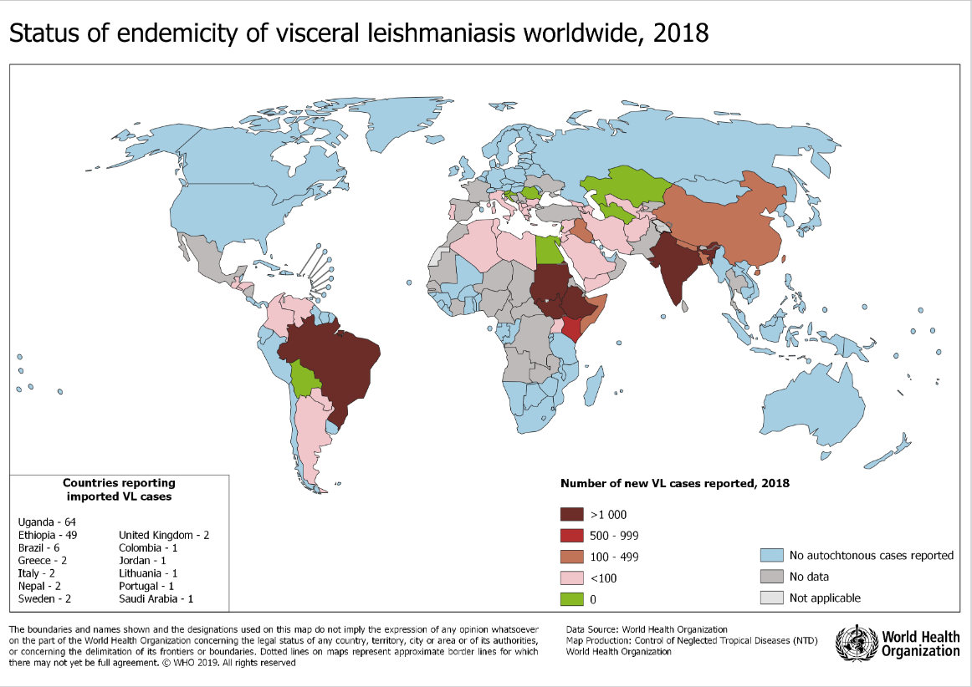
Figure 1 [1]
The life cycle of the leishmaniasis parasite starts when a female phlebotomine sand-fly carrying Leishmania parasites feeds on a human and injects the infective stage, promastigotes, from their proboscis during a blood meal. Promastigotes that are injected into the human are phagocytosed by macrophages or other types of mononuclear phagocyte cells. Promastigotes transform in these cells into amastigotes (tissue stage of the parasite), which multiply by simple division and proceed to infect other cells. Many factors from the parasite, host and environment influence whether the infection will evolve with symptoms and disease. Sandflies become infected when they ingest infected cells during a blood meal. In the sand-fly, amastigotes transform into promastigotes in the gut and migrate to the proboscis.

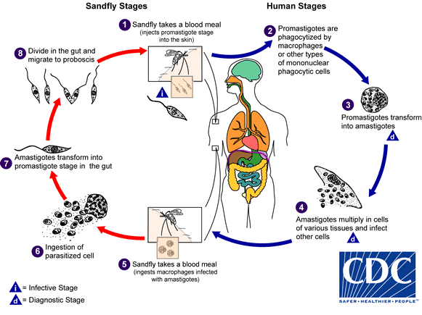
Figure 2 [2]

In VL research studies, data should be collected on the factors that may affect the VL therapeutic efficacy, as well as safety and tolerability results. Subjects are heterogeneous, differing in region, age, nutritional status, baseline parasite density, previous treatments for VL, co-morbidities and immune function. Lower age, severe malnutrition, severe anemia, other signs of severe disease (such as jaundice, bleeding, oedema), HIV co-infection, and co-morbidities are associated with poor treatment outcome. Therefore, all these parameters need to be taken into consideration when designing a VL clinical trial; and should be systematically recorded.

Additional information can be found at the following websites:
- World Health Organisation ‘blue book’, Control of Leishmaniasis [https://apps.who.int/iris/bitstream/handle/10665/44412/WHO_TRS_949_eng.pdf;jsessionid=E5D2EFF9429AC800C1E57A226036D886?sequence=1]
- Infectious Diseases Data Observatory (IDDO) [www.iddo.org]
- Pan American Health Organization (PAHO), Manual of procedures for leishmaniases surveillance and control in the Americas
[https://iris.paho.org/handle/10665.2/51838]

- Centers for Disease Control and Prevention [https://www.cdc.gov/parasites/leishmaniasis/index.html]
- Diagnosis and Treatment of Leishmaniasis: Clinical Practice Guidelines by the Infectious Diseases Society of America (IDSA) and the American Society of Tropical Medicine and Hygiene (ASTMH) [https://pubmed.ncbi.nlm.nih.gov/27941143/]

Timing Considerations
Historically in many VL treatment clinical trials, the day the subject is enrolled and receives the first dose of treatment for VL, has been considered Day 0 and the first day post dose has been considered Day 1. However, in the Study Data Tabulation Model (STDM)-based domains, a Study Day of 0 is not allowed, and this day should be represented as Study Day 1. Thus, for example, days 0, 1, 3, 7, 14 and 28 for disease assessment, translate to SDTM Study Day (--DY) 1, 4, 8, 15 and 29. To avoid confusion, the language in this guide refers to hours, days, and weeks post first dose when referencing the timing of disease assessments. In SDTM examples, the convention for assigning Study Day as described above will be used. For further explanation on this convention, see Section 4.1.4.4 "Use of the “Study Day” Variables" of the SDTMIG v3.3.

Subject and Disease Characteristics
Information about subject and disease characteristics generally includes events and activities that have affected the subject prior to the study. For VL studies, such information may include subject characteristics such as demography (age, sex, ethnicity), eligibility (inclusion/exclusion criteria), medical history (allergies, known contraindication to study drug/s, comorbidities), and previous medications (anti-leishmanial taken in preceding weeks, concomitant/recent non-study medication). The sub-sections below describe this information in detail and show corresponding SDTM-based examples.

Inclusion/Exclusion Criteria
A subject who presents with symptoms of VL and a leishmaniasis-positive examination of a tissue aspirate from spleen, bone marrow or lymph node, is defined as having VL. As severe anemia is associated with poor treatment outcome, it is recommended that only subjects with haemoglobin > 5g/dL are enrolled in clinical trials. Patients presenting relapse (recurrence of VL), HIV co-infection, severe VL and severe malnutrition are usually excluded from clinical trials, as these conditions are also associated with poor outcome, and these patients require special case management. Subjects with a medical history (or pharmacokinetic evidence) of recent prior anti-leishmanial use are generally excluded from clinical trials. Other exclusion criteria may include hypersensitivity or other contraindications to the study drug, or inability to tolerate oral medication (if relevant), as well as high-risk populations (e.g. pregnant women, breast feeding women, infants, comorbidities and the elderly[6]). However, as young children, pregnant women, and those with comorbidities carry a high VL burden, when possible they should be included in later phase clinical trials[7].
Miltefosine (IMPAVIDO) is contraindicated in patients who have Sjögren-Larsson-Syndrome.[8]

Demographics
The FDA has recently published guidance on enhancing diversity in clinical trials[7], which recommends ways in which vulnerable populations previously excluded from clinical trials such as pregnant women and those under nourished could be included.
As there are differences between specific requirements relating to the collection of age and date of birth, and race and ethnicity between regions where VL is endemic, mainly South Asia, East Africa and Brazil, demographic information will need to be adapted to the relevant region requirements (see section known issues).

Baseline Assessments
Evaluating VL subjects may include the collection of medical history, as well as recording symptoms of the disease, and characteristics of the subject based on physical examination and special investigations, such as laboratory tests, audiometric testing (for drugs affecting hearing) and electrocardiograms (ECGs). Medical history helps to confirm the diagnosis, exclude Post-kala-azar VL (PKDL), identify underlying risk factors (e.g., pregnancy, comorbidities such as HIV co-infection, malaria and malnutrition) and recent use of anti-leishmanials, as well as any concomitant medication use and previous medical history that is necessary for the interpretation of adverse events (AEs). Physical characteristics of the subject can include body weight, height, body mass index (BMI), vital signs, spleen and liver sizes, signs of bleeding, jaundice, etc, as well as whether or not any abnormalities were detected upon physical examination and special investigations.

Medical History and Symptoms
Medical history important to VL includes time since onset of symptoms, previous treatment(s) for VL (antibodies from a previous case can remain detectable for years after treatment), symptoms, known contraindications to study drug(s), and comorbidities.

Prior and Concomitant Medications
In VL trials, it may be important to collect information regarding anti-leishmanial treatments taken in a protocol-defined period preceding the study and other concomitant/recent non-study medication.
Due to the prevalence of HIV, malaria, tuberculosis and other bacterial co-infections, frequent concomitant medications among VL-infected subjects include antiretroviral, anti-tuberculous, antibiotics and antimalarial drugs. These types of data should be represented in the Concomitant Medications (CM) domain, including the start and end dates. Examples of this modeling can be found in the CDISC SDTMIG.[9]

Disease Assessments
Disease assessments are typically done repeatedly over the course of a study and are used to evaluate how a subject is responding to treatment. Studies on treatments for VL usually include prospective evaluations of clinical and haematological responses at least at baseline, on the day of enrollment (start of treatment/VISIT1) and then at Day3, Day7, Day14, Day28 and end of study follow-up time as specified in the protocol. An adequate duration of follow-up is needed in order to detect initial no-response to treatment or relapse in the months following the end of treatment. A study's length of follow-up will depend on the drug(s) being tested, the population being studied and the half-life of the study drug. A follow-up period of 6 months is the usual practice in VL trials; however, in Asia, longer periods of follow-up (12 months) may be indicated, depending on the drugs under investigation. In addition, if a study has the interest to measure occurrence of PKDL after the VL treatment (as an outcome of interest), then longer follow-up of at least 24 months is recommended in Asia. For information about representing Study Days in SDTM datasets, please see Section 2 Timing Considerations.

Disease assessments are composed of medical history, clinical, and laboratory assessments. Clinical assessments usually include body temperature and vital signs, examination for malnutrition, splenomegaly, hepatomegaly, presence of lymphadenopathy and signs of PKDL. Monitoring for reduction in fever, spleen and liver size at follow-up visits is important for assessing drug efficacy. Laboratory assessments usually include microscopy of tissue aspirate (spleen, liver or lymph node) to determine the presence or absence of parasites at enrolment and day 28, if present the number of parasites is graded; haemoglobin/hematocrit, WBC and platelets, laboratory indicators of liver toxicity, and other safety laboratory parameters (based on the toxicity profile of the investigational drug) are usually recorded at all scheduled study visits during treatment period, and selected parameters are recorded during follow-up period.

Although the assessment of VL biomarkers by PCR or qPCR has not yet been validated, these might be included in the protocol as they could be useful tools to describe parasite dynamics and define treatment response for each subject, and in time may be considered as part of the efficacy end-point measures, secondary outcome measures, or other possible outcomes. The following sub-sections discuss each of these common assessments in more detail.

Visceral leishmaniasis Symptoms
The signs and symptoms of VL are non-specific. VL is suspected clinically primarily on the basis of fever for at least 2 weeks (with or without rigors), enlarged spleen, weight loss or wasting, enlarged lymph nodes on examination and anaemia; hepatomegaly is also commonly found along with cough, nose bleeds, diarrhoea and vomiting. Symptoms progress gradually, sometimes over the period of a few months, and almost all patients will die if not treated.

When a symptom is present at the beginning of the study, information about this symptom is represented as an event in the Medical History (MH) domain. If the symptom continues but does not increase in severity at follow-up, information about this symptom is represented as a Clinical Event. However, if the symptom worsens, or new symptoms appear at follow-up, information about this symptom may be represented as an AE. The study protocol will guide how these data should be collected, which symptoms are of particular interest, and when a symptom should be considered a Clinical Event or an AE. For examples of mapping CDASH to STDM see malaria-TAUG.

VL Diagnosis
In Africa and Asia identification of parasites by microscopy (parasitological diagnosis) at baseline and end of treatment (test of cure) remains the gold standard in clinical research, however in Brazil even though the parasitological diagnosis is made at baseline, the test of cure is not performed, and assessment at end of treatment is made by clinical parameters only.
- Parasitological diagnosis: Microscopic examination of Giemsa-stained spleen, bone marrow or lymph node aspirates to detect amastigotes remains the reference standard for VL diagnosis in clinical research. However, these methods are either invasive (spleen and bone marrow) or insensitive (lymph node). The sensitivity of lymph node aspiration is 52–65%, where-as the sensitivity of bone marrow aspiration can reach up to 75% (refs). Splenic aspiration sensitivity is 90–95%. However, negative slides do not prove absence of the parasite, and low parasite density can be missed microscopically. Lymph node aspiration (mainly done in Sudan) is safe, easy and can be done by paramedical staff compared with bone marrow aspiration, which is painful and needs specific and sterile needles, and trained personnel. Spleen aspiration is the most sensitive procedure, but it may be hazardous. Once the parasites have been counted in microscopy these are graded. [10]
- Serologic diagnosis: Several immunological blood tests that identify specific antibodies against Leishmania in the blood or serum of patients with VL are available. A limitation of these tests is that antibodies can remain detectable up to several years after cure, and a significant proportion of healthy people living in endemic areas with no history of VL are positive for Leishmania antibodies. Therefore, they cannot distinguish between active VL and subclinical and past infection and should be used only for suspect cases of VL. In addition, such tests cannot be used for diagnosis of relapse or for evaluation of cure.
  - Rapid diagnostic test (RDT) with a recombinant K39 antigen (rK39) immunochromatographic test (ICT) are easy to perform, therefore useful in field settings. Examples of these tests are K39 ICT manufactured by Bio-Rad (previously DiaMed) and IT-LEISH. In clinical trials, the RDTs are mainly used for initial screening for VL. However, as an antibody detection test, the rK39 ICT cannot be used for the diagnosis of relapse and/or as a test of cure. RDTs employing other antigens are also under evaluation, e.g. rK28 RDT.
  - The direct agglutination test (DAT). This test has been well validated but is more complex to perform thanks RDT, it requires health facilities with well trained staff and cold chain management.
Rapid Diagnostic Test (RDT)
This example demonstrates how to represent data from a rapid diagnostic test for visceral leishmaniasis for two participants at the screening visit. The variables MBTESTCD and MBTEST represent the antigen that is being assessed by the test. If needed, the manufacturer, trade name and lot number of the assay can be represented in the Device Identifiers (DI) domain and can be mapped to the records in MB using the SPDEVID variable.
Example 1
Shows the screening of subject 201 and 202 for the detection of rK39 (antibody to the Leishmania parasite), performed at the baseline visit. Subject 201 positive for rK39 antibodies, indicating a positive result, whereas subject 202 tested negative rK39 antibodies.
Row | STUDYID | DOMAIN | USUBID | SPDEVID | MBSEQ | MBTESTCD | MBTEST | MBTSTDTL | MBCAT | MBORRES | MBSPEC | MBMETHOD | VISITNUM | VISIT | MBDTC
1 | ABC | MB | ABC-1-201 | 123 | 1 | RK39AG | Leishmania rK39 antibody | DETECTION | LEISCHMANIASIS DIAGNOSIS | POSITIVE | SERUM | IMMUNOASSAY | 1 | BASELINE | 2019-04-29
2 | ABC | MB | ABC-1-202 | 456 | 1 | RK39AG | Leishmania rK39 antibody | DETECTION | LEISCHMANIASIS DIAGNOSIS | NEGATIVE | SERUM | IMMUNOASSAY | 1 | BASELINE | 2019-04-29

Row | STUDYID | DOMAIN | SPDEVID | DISEQ | DIPARMCD | DIPARM | DIVAL
1 | ABC | DI | 123 | 1 | DEVTYPE | Device Type | VL Rapid Diagnostic Test
2 | ABC | DI | 123 | 2 | TRADENAM | Trade Name | DiaMed‐ITLEISH
3 | ABC | DI | 123 | 3 | MANUFACTURER | Manufacturer | Bio‐RadLaboratories
4 | ABC | DI | 123 | 4 | LOT | Lot | 123456
5 | ABC | DI | 456 | 1 | DEVTYPE | Device Type | VL Rapid Diagnostic Test
6 | ABC | DI | 456 | 2 | TRADENAM | Trade Name | KalazarDetect™
7 | ABC | DI | 456 | 3 | LOT | Manufacturer | InBiosInternationalInc.
8 | ABC | DI | 456 | 3 | LOT | Lot | 234567

Figure 3: Schematic representation of the diagnosis of visceral leishmaniasis

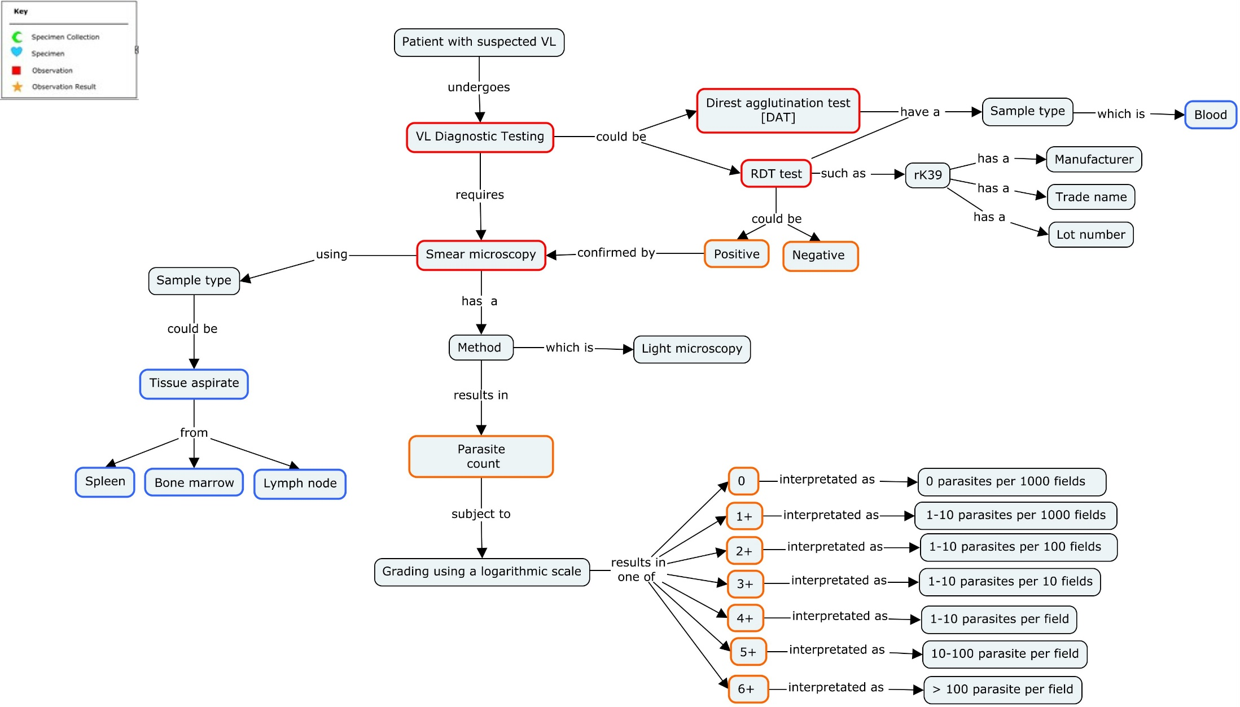

Microscopy

Example 1:
This example shows microscopy data from two subjects, one where the location of the specimen is bone marrow (rows 1 and 2) and the other location is from spleen (rows 3 and 4).
Row 1 and 2: Row 1 shows a test looking for the presence or absence of Leishmania using smear microscopy, row 2 shows the quantification/grading of the parasite load from a tissue specimen taken from bone marrow.
Row 3 and 4: Row 3 shows a test looking for the presence or absence of Leishmania using smear microscopy, row 4 shows the quantification/grading of the parasite load from a tissue specimen taken from bone marrow.
Row | STUDYID | DOMAIN | USUBID | MBSEQ | MBTESTCD | MBTEST | MBTSTDTL | MBCAT | MBORRES | MBSPEC | MBLOC | MBMETHOD | VISIT | MBDTC
1 | ABC | MB | ABC-1-201 | 1 | LEISCH | Leishmaniasis | DETECTION | LEISCHMANIASIS DIAGNOSIS | POSITIVE | TISSUE | BONE MARROW | LIGHT MICROSCOPY | BASELINE | 2019-04-28
2 | ABC | MB | ABC-1-201 | 2 | LEISCH | Leishmaniasis | QUANTIFICATION | LEISCHMANIASIS DIAGNOSIS | GRADE 4 | TISSUE | BONE MARROW | LIGHT MICROSCOPY | BASELINE | 2019-04-28
3 | ABC | MB | ABC-1-202 | 1 | LEISCH | Leishmaniasis | DETECTION | LEISCHMANIASIS DIAGNOSIS | POSITIVE | TISSUE | SPLEEN | LIGHT MICROSCOPY | BASELINE | 2019-04-29
4 | ABC | MB | ABC-1-202 | 2 | LEISCH | Leishmaniasis | QUANTIFICATION | LEISCHMANIASIS DIAGNOSIS | GRADE 2 | TISSUE | SPLEEN | LIGHT MICROSCOPY | BASELINE | 2019-04-29

VL Efficacy Outcomes
In clinical trials, subjects with VL are followed-up regularly for a fixed period of time to monitor for clinical signs of disease and any recurrence of parasites after parasite clearance. This fixed time period is typically 6 months, with an initial assessment at 28 days after first dose to guide clinical practice. Initial cure and therapeutic responses are classified by the definitions agreed by the VL working group (see appendix 7.1 for members). Generally, efficacy outcomes are derived during analysis but sometimes this data is additionally captured on the CRF at the trial investigational site. When this occurs, the data collected on the CRF is represented in the SDTM Disease Response (RS) domain.
Subjects that are not assessed at Day 28, will not have an initial outcome result, and the reason for non-attendance will be recorded in the study disposition. Reasons for non-attendance may include AE/serious AE (SAE) (non-fatal), death (related or not to VL), lost to follow-up, withdrawal by investigator, or withdrawal by subject/guardian.

The concept map below illustrates treatment response for VL.

Figure 4: Schematic representation of treatment response from Day1 through follow-up

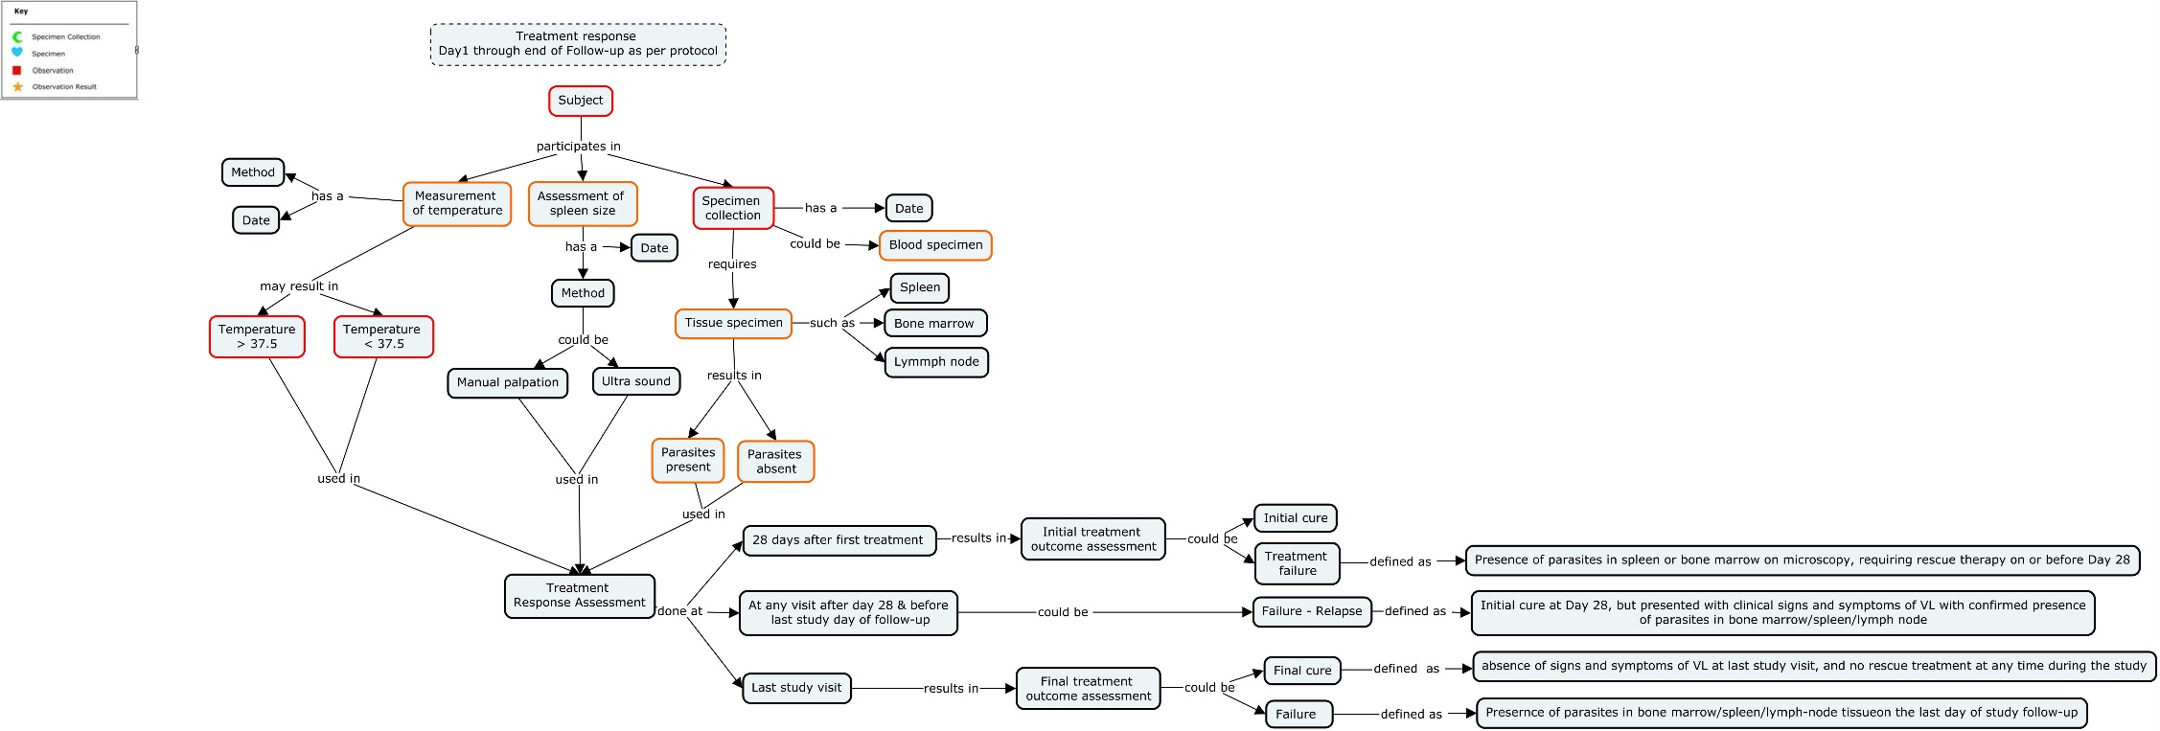
Figure 4:

Routinely Collected Data
This section covers data that are collected in most VL studies, including laboratory tests, AEs and concomitant medications. These and other related topics are covered in detail, along with SDTM examples.

Site and Trial Level Data
Often, there are data that are the same across all subjects within a study or site that need to be represented in an SDTM dataset. Instead of duplicating this information for each subject, it may be appropriate to use either the Trial Summary (TS) domain or the Site Summary (SI) domain. The TS domain accommodates data that need to be represented at the study level, while the SI domain is used to represent data that vary by site, but not by subject. For VL trials, an example of trial level data is the amount of blood collected for a particular test, as defined by the protocol. An example of site level data could be the device information of RDTs if sites were to use RDTs from different manufactures. Sponsors should work closely with the appropriate regulatory authority to determine which data should be represented at the site and/or trial level.

Note: The example in this section make use of a draft domain called Site Summary (SI). Users may wish to review it here to aid in their interpretation of the example.

Anti-leishmanial Treatment Administration
Drugs used to treat VL include amphotericin B, pentavalent antimonial drugs, paromomycin (a parenteral aminoglycoside), and miltefosine. Miltefosine was the first oral treatment for this disease, with a conventional 28-day treatment regimen when used as monotherapy. If amphotericin is given, the formulation (such as Liposomal, B Lipid complex or Colloidal dispersion) should be listed in the protocol and included in the trial summary dataset.

Combination Therapy
With the limitations of the currently existing drugs, there was an interest among experts that antileishmanial therapy in endemic regions should move toward combination drug therapy to improve efficacy and safety/tolerability, explore shorter treatment courses, and possibly prevent resistance development. Sodium stibogluconate/paromomycin SSG/PM (17 days) in Africa, and Miltefosine/Paromomycin PM/MF (10 days) in Asia are examples of combination therapies currently recommended.

Post Dose Vomiting
After a subject is treated with an oral anti-leishmanial, they should be monitored for vomiting. If vomiting occurs within a period of time pre-specified in the protocol, the subject may be re-dosed. Depending on the amount of time that has passed, the re-dose may be a full or partial dose. A full dose is usually repeated if the vomiting occurred shortly after dosing, but a partial dose may be given if vomiting occurred after a defined number of minutes according to the protocol. See TAUG-malaria for mapping concepts illustrating vomiting after dosing and redosing.
See TAUG-malaria for examples of post-dose vomiting mapping.

Laboratory Tests of Special Interest
Laboratory tests of special interest to VL studies may include those used to assess VL disease severity. Pregnancy tests may be performed on women of child-bearing age at baseline and repeated at study completion. Laboratory tests are also used to monitor for AEs, including AEs of special interest (see the Adverse Events of Special Interest section).
LBTESTCD | LBTEST | LBSPEC
HGB | Haemoglobin | WHOLE BLOOD
WBC | White Cell Count | WHOLE BLOOD
NEUT | Neutrophils | WHOLE BLOOD
BASO | Basophils | WHOLE BLOOD
LYM | Lymphocytes | WHOLE BLOOD
MONO | Monocytes | WHOLE BLOOD
EOS | Eosinophils | WHOLE BLOOD
PLAT | Platelets | WHOLE BLOOD
AST | AST | WHOLE BLOOD
ALT | ALT | WHOLE BLOOD
BILI | Total Bilirubin | WHOLE BLOOD
BILDIR | Direct (conjugated) bilirubin | WHOLE BLOOD
CREAT | Creatinine | WHOLE BLOOD
ALB | Albumin | WHOLE BLOOD
GLUC | Glucose | WHOLE BLOOD

Haemoglobin
In studies on the treatment of VL, haemoglobin may be monitored regularly throughout follow up, at least at enrollment (baseline) and on days 7, 14, and 28 post first dose; subsequently during follow-up at D56 and D180. While a response to treatment is usually associated with an increase in haemoglobin, there may initially be a slight decrease within the first week of treatment. A decrease in haemoglobin below 5g/dL could indicate progression to severe disease and thus require investigation and special patient management (including blood transfusion, if indicated). Rescue treatment is indicated in case of confirmed treatment failure.

Safety Monitoring
If an AE occurs, an AE and/or SAE record is collected in the usual manner (see the SDTMIG AE domain and CDASH SAE supplement). Records pertaining to vital signs are represented in the Vital Signs (VS) domain. Laboratory results, such as liver function tests and serum amylase/lipase for pancreatitis, are represented in Laboratory Test Results (LB) domain or in the case of virus identification results, the Microbiology Specimen (MB) domain.

Adverse Events of Special Interest
An AE of special interest is one of scientific and medical concern to the sponsor’s product or program so will depend on the drug or drug combination under study. It may therefore be monitored and characterized by further investigation and potentially warrant rapid communication by the sponsor to other parties (e.g., regulators). AEs of special interest may or may not, however, be adverse drug reactions (ADRs), which are those effects reasonably associated with use of the drug.[11-13]. Some currently available anti-leishmanial drugs have a known potential for severe ADRs, while relatively less severe ADRs can also be important to patients and affect adherence. Some subjects may be more susceptible to harm due to their age, medical history and/or concomitant medications, and it can be difficult sometimes to differentiate manifestations of the disease from drug effects. Systematic close monitoring of these parameters and concerns identified from preclinical or early clinical trials may therefore be specified in protocols. Among current anti-leishmanial treatments, investigations have included hepatic, nephrotic and pancreatic toxicities, ECG changes and hearing loss. In addition, AEs of special interest may be detailed in the protocol, such as anaphylactic reaction or Stevens-Johnson syndrome. Teratogenicity may also be an important concern, despite exclusion criteria and pregnancy tests and requirement for appropriate contraception for women of childbearing age (e.g. miltefosine).

Drug induced liver injury (DILI)
The pentavalent antimonials are known to raise liver enzymes, which can be severe enough to interrupt treatment[14] . Determining whether DILI is related to a particular drug is, however, challenging as there may be other causal or contributory factors: underlying morbidity (e.g., viral hepatitis, malignancy), concomitant medicines (including traditional, alternative and complementary medicines) or alcohol, or patient characteristics (e.g., increased age, genetic factors). The US Food and Drug Administration (FDA) considers findings of 1 or more cases of Hy's Law in subjects given an investigational drug as the main predictor for drugs likely to be capable of causing severe liver injury; a ≥ 3-fold elevation above the upper limit of normal (ULN) for ALT or aspartate aminotransferase (AST) and a total bilirubin > 2 times the ULN, with no other explanations.[15] Along with extensive hematology and biochemistry panels, tests for blood alcohol and a hepatitis panel are usually indicated.

Cardiovascular events/Electrocardiograph changes
The pentavalent antimonials are also known to cause adverse cardiac effects, such as QT interval prolongation, arrhythmias, ventricular disorders, and potentially sudden death through fatal Torsade de pointe (TdP), especially in the elderly[14, 16]). Amphotericin B deoxycholate meanwhile can cause myocarditis/cardiomyopathy. Adequate characterization of any new drug's effects on the QT/QTc intervals is required during pre-marketing clinical studies (corrected for heart rate dependence through methods such as Fredericia and Bazett: QTcF and QTcB).[17, 18] When interpreting abnormal ECG results, information about the subject's age, medical history, and related symptoms are important to consider in determining a diagnosis and relationship of the event to the trial drug. The trial drug's concentrations may be influenced by interactions with other drugs or food, so concomitant medication and food consumption data are collected and considered with other important variables including vital signs, laboratory assessments (e.g., electrolytes such as calcium and potassium, other cardiac assessments (e.g., echocardiogram), and potentially genotyping for cardiac ion channel mutations. These will be protocol specific, depending on the drug, trial design, or clinically indicated by the event itself. An example of an ECG assessment assuming a standard device is given in the annotated VL CRF (aCRF) template and associated SDTM. If a cardiovascular AE has occurred, an AE and/or SAE record is collected in the usual manner (see the SDTMIG AE domain and CDASH SAE supplement). For SDTM, records pertaining to vital signs and laboratory tests will be in the VS and LB domains, respectively, as indicated above.

Pancreatitis
Certain co-morbidities and medications may increase risk of pancreatitis in patients with VL. For instance people living with HIV are susceptible to underlying pancreatitis, which can be exacerbated in HIV-VL co-infections and with drug treatments, including the antiretrovirals and/or pentavalent antimonials[16] [19].

Nephrotoxicity
Amphotericin B deoxycholate commonly causes severe nephrotoxicity and hypokalemia, although liposomal formulations do minimize these adverse effects. Meanwhile, elevated serum creatinine in miltefosine trials has been proposed as possibly related to dehydration due to severe vomiting and diarrhoea[20].

Ototoxicity
Hearing loss is a known side effect of aminoglycoside antibiotics, a class of drug to which the VL drug paromomycin is related. Audiometry was therefore used in paromomycin clinical trials with a phase 3 trial finding of 2% reversible hearing loss in the paromomycin arm [21] audiometry. The Records pertaining to audiometry will be represented in a custom domain based on the body systems domain suggested name (abbreviation) of Audiometric (AU), see appendix C of the aCRF.

Pharmacokinetics
For VL, pharmacokinetic measures are important components of clinical trials for new or re-purposed drugs. Measuring concentrations of the drug and/or metabolites of the drug over time in body fluids and tissues helps determine optimum dosing regimens for curing the disease and understanding pharmacokinetic parameter differences in special populations such as pregnant women and children.[22] Data on concentrations of drugs/metabolites in fluids or tissues as a function of time are represented in the PC domain. Parameters derived from concentration curves constructed from repeated sampling over time (e.g., area under the curve, time of maximum concentration) are represented in the PP domain. Since there is nothing unique about pharmacokinetic data for VL drugs compared to data for drugs that treat other diseases, please refer to the CDISC SDTM Implementation Guide Version 3.2, Section 6.3 Pharmacokinetic Domains for examples and descriptions of these domains.

Sometimes pharmacokinetic assays use blood that has been blotted and dried on filter paper. These types of samples can be especially helpful in resource poor settings, as these samples do not need to be refrigerated and are easier to ship than samples stored in tubes. When tests use this type of sample, variable --SPEC should be populated with the type of blood used such as "BLOOD" and --SPCCND should be populated with "DRIED".

Analysis Considerations
This section describes the derivation logic to support the analysis of efficacy endpoints in VL studies for treatment outcome, fever clearance, reduction of spleen size and changes in haemoglobin. It is important to note that the examples in this section were chosen to illustrate different concepts and data structures. The examples are therefore not meant to be applicable to every possible VL study. The study objectives and primary endpoints will dictate the actual analyses that are performed. In summary, these examples are not meant to make recommendations as to the use of these endpoints, the methods for the endpoints, nor the exact statistical methodology. This section does not provide examples of the use of the CDISC Analysis Data Model (ADaM) standard for the development of efficacy analysis data sets, although in practice, the use of ADaM is encouraged since the defined standard structures can support these analyses and the resulting analysis data sets would have necessary traceability to the source SDTM data. Readers are encouraged to refer to Version 2.1 of the ADaM and Version 1.0 of the ADaM Implementation Guide (ADaMIG) for background about the ADaM and the ADaM data structures.

Subject Level Analysis Data
In clinical trial analyses, it is typical to develop a record per subject dataset that contains variables that are important for describing the subject’s characteristics and important trial events, dates, and treatment information. Examples of typical variables include population flags, planned and actual treatment, demographic information, randomization factors, baseline values of important measures and dates.

Specifically for VL, covariates such as medical history events of interest (e.g., previous treatment for VL, history of fever etc.) and baseline values (e.g., body temperature, antileishmanial treatment received, baseline laboratory values (haematology and chemistry) and baseline parasite grade are typically used in this subject level data set.

Analysis of Efficacy Outcome
In VL efficacy trials, subjects are followed-up for a fixed period of time to monitor for improvement in clinical signs of disease (especially fever, spleen size and haematological parameters such as haemoglobin), parasite reduction, and any recurrence of clinical signs and symptoms of the disease with parasitological confirmation during follow-up. The follow-up period will be specified in the protocol and is usually 6 months.

In VL studies, even though treatment regimen may vary in duration, the so called ‘treatment period’ is usually of 28 days, at which point the patient should be assessed for initial response to treatment classified as:
- Initial cure: Clinical improvement, defined as improvement of clinical signs and symptoms (absence of fever attributed to VL, reduction in spleen size and improvement of haematological parameters); absence of parasites in the spleen or bone marrow microscopy, and no rescue therapy on or before Day 28
- Initial failure: Presence of parasites in spleen or bone marrow on microscopy, requiring rescue therapy on or before Day 28

Efficacy Outcomes

Overall response to treatment will be assessed on the last study visit in confirmatory trials. Disease response is classified as:
- Final cure: Absence of signs and symptoms of VL at last scheduled study visit (such as Day 180), and no rescue treatment at any time during the study
- Failure – Initial Failure: presence of parasites in spleen or bone marrow on microscopy, requiring rescue therapy at or before day 28
- Failure – Relapse: Initial cure at Day 28, but presented with clinical signs and symptoms of VL with confirmed presence of parasites in spleen or bone marrow on microscopy after day 28
- Failure – Treatment discontinuation due to (S)AE related to the study drug, requiring rescue therapy.
- Failure – Death associated with VL or related to the study drug
- Other – Non-completion due to withdrawal, death not related to VL, lost to follow up, protocol violation etc

Efficacy Outcome Analysis Results
Results are commonly expressed as cumulative response rates, that are:
- Number and proportion of subjects that were classified as cured
- Number and proportion of initial failure
- Number and proportion of failure due to relapse
- Number and proportion of treatment discontinuations and reasons

Cure rates are generally reported as number/total, proportion cured and 95% confidence intervals (95%CI), the chi squared test (or exact as appropriate) are used to determine significance. Subgroup analysis may be performed according to important pre-defined baseline covariates (e.g., anti-leishmanial treatment, age category, baseline parasite density, baseline haemoglobin). The study protocol and the statistical analysis plan (SAP) should specify which baseline data to include.

Analysis of Temperature Data
In VL trials, there is often interest in analyzing the time it takes for a fever to clear. Fever clearance time is defined as the time of the first temperature measurement below the fever threshold (e.g. 37.5 degrees Celsius), which remained below that threshold over the following 72 hours (or as defined by the SAP). Precision of fever clearance time depends on the frequency of temperature measurements.

Analysis of Haematological Data
The source for the Haemoglobin dataset is the SDTM laboratory results (LB) domain. It includes the Haemoglobin (Hgb) measurements taken over time. In addition, in VL pancytopenia is common so white blood cell count, platelets and differential counts are also very important and should be monitored systematically.

In the analysis of haemoglobin data, the focus is on the hematological status of subjects at particular timepoints, as well as on changes in Hgb over time. The timepoints may include all visits or at screening/enrollment at Day 1, Day 3, Day 7, Day 14, Day 28, and at the end of follow-up. Anaemia and its severity is defined as Hgb below a pre-specified level as referenced in a specific grading scale such as Common Terminology Criteria for Adverse Events CTCAE[23], which will be documented in the study protocol. This cut-off can vary for different subgroups of subjects (i.e., children, women, pregnant women).

Often, there is interest in analyzing any change from previous visits. The change in Hgb between times t_{i} and t_{j} is defined as hgb(t_{j})- hgb(t_{i}) and percent change in Hgb between times t_{i} and t_{j} is defined as (hgb(t_{j})- hgb(t_{i})*100)/hgb(t_{i}), where hgb(t_{i}) and hgb(t_{j}) denotes measured or estimated Hgb at time t_{i} and t_{j}. The change from baseline and percent change from baseline in Hbg at each timepoint is an important measure for assessing the safety of the subjects.

Haemoglobin Data Analysis Results
VL patients usually present with a very low haemoglobin, which improves over time. To monitor improvement of haemoglobin over time the mean and standard deviation of Hgb at each visit as well as the proportion of subjects with anaemia may be presented. This is generally accompanied by a figure to illustrate changes in Hgb over time.
If additional baseline data are available, these outcomes are generally stratified according to important pre-defined baseline confounding variables (e.g., anti-leishmanial treatment, age category, baseline parasite grade). An appropriate analysis as defined in the SAP is used to identify factors independently associated with outcomes.

Spleen Size Analysis
Spleen size is usually measured by either palpation or on ultrasound, and commonly measured at baseline and assessed throughout the study as reduction of spleen size which usually occurs soon after treatment has been started, and is used as a clinical sign to determine response to treatment. On manual palpation, spleen size is measured with a tape meter from the left mid-clavicular line from the costal margin to the tip of the organ, on its longest axis. ; ultrasound measures the length of the spleen along a center line, and the width and thickness of the spleen; spleen size is measured in centimeters (cm).

Appendices

Project Team
VL aCRF project team.
Name | Institution/Organization
Dr Fabiana Alves | DNDi
Dr Suman Rijal | DNDi
Prof Philippe Guerin | IDDO
Mathew Brack | IDDO
Kalynn Kennon | IDDO
Michael Otieno | DNDi
Lesley Workman | IDDO
Dr Elizabeth Allen | IDDO
Bess LeRoy | CDISC
Jon Neville | CDISC

Project Collaborators
The VL aCRF project team are very grateful to the following individuals for their support in creating this VL community-developed standard aCRF.

Name | Institution/Organization | Name | Institution/Organization
Dr Jorge Alvar | DNDi | Dr Sachin Naik | Novartis
Dr Gerhild Angyalosi | Novartis | Dr Sheral Patel | U.S. FDA
Dr Sakib Burza | MSF | Dr Eric Pelfrene | EMA
Dr Gwenaelle Carn | DNDi | Dr Manju Rahi | ICMR
Prof Mitali Chatterjee | IPGMER | Sheeraz Raja | DNDi
Prof Carlos Costa | Federal University of Piauí | Dr Koert Ritmeijer | MSF
Dr Isra Cruz | Instituto de Salud Carlos III Madrid | Dr Joelle Rode | DNDi
Dr Pradeep Das | RMRIMS | Prof Gustavo Romero | University of Brasília
Dr Susan Dixon | GlaxoSmithKline | Dr Agnès Saint-Raymond | EMA
Dr Lise Grout | WHO | Dr Ruchi Singh | ICMR
Dr Saurabh Jain | WHO | Alexandra Solomos | DNDi
Dr Amresh Kumar | PATH | Prof Shyam Sundar | KAMRC
Dr Kayla Laserson | Bill & Melinda Gates Foundation | Karthik Sundaramoorthy | Novartis
Dr Raman Mahajan | MSF | Dr Bhupendra Tripathi | Bill & Melinda Gates Foundation
Dr Paritosh Malaviya | KAMRC | Md. Rasel Uddin | icddr,b
Dr Rezika Mohammed | University of Gondar | Kapil Varshney | Novartis
Dr Dinesh Mondal | icddr,b | Dr Saravanan Vijayakumar | RMRIMS
Prof Ahmed Musa | IEND

Glossary and Abbreviations
ADaM | Analysis Data Model
AE | Adverse event
Biomedical Concept | A high-level building block of clinical research and/or healthcare information that encapsulates lower level implementation details like variables and terminologies
BMI | Body Mass Index
CDASH | Clinical Data Acquisition Standards Harmonization Project
CDASHIG | CDASH Implementation Guide
CDISC | Clinical Data Interchange Standards Consortium
Collected | “Collected” refers to information that is recorded and/or transmitted to the sponsor. This includes data entered by the site on CRFs/eCRFs as well as vendor data such as core lab data. This term is a synonym for “captured”.
Controlled Terminology | A finite set of values that represent the only allowed values for a data item. These values may be codes, text, or numeric. A code list is one type of controlled terminology.
CRF | Case report form (sometimes called a case record form). A printed, optical, or electronic document designed to record all required information to be reported to the sponsor for each trial subject.
CTCAE | Common Terminology Criteria for Adverse Events
DNDi | Drugs for Neglected Diseases initiative
Domain | A collection of observations with a topic-specific commonality about a subject
ECG | Electrocardiogram
eCRF | Electronic case report form
EMA | European Medicines Agency
FDA | U.S. Food and Drug Administration
Foundational Standards | Used to refer to the suite of CDISC standards that describe the clinical study protocol (Protocol), design (Study Design), data collection (CDASH), laboratory work (Lab), analysis (ADaM), and data tabulation (SDTM and SEND). See http://www.cdisc.org/ for more information on each of these clinical data standards.
HIV | Human immunodeficiency virus
icddr,b | International Centre for Diarrhoeal Disease Research, Bangladesh
ICMR | Indian Council of Medical Research
IDDO | Infectious Diseases Data Observatory
IEND | Institute of Endemic Diseases, University of Khartoum
IPGMER | Institute of Post Graduate Medical Education and Research, Kolkata, India
KAMRC | Kala-Azar Medical Research Centre, Muzaffarpur, Bihar, India
MSF | Médecins Sans Frontières
NCI EVS | National Cancer Institute (NCI) Enterprise Vocabulary Services
NIAID | National Institute of Allergy and Infectious Diseases
NIH | National Institutes of Health
Patient | A recipient of medical treatment.
PCR | Polymerase chain reaction
PKDL | Post-kala-azar dermal leishmaniasis
PM/MF | Miltefosine/Paromomycin
RBC | Red blood cell
RDT | Rapid diagnostic test
RMRIMS | ICMR-Rajendra Memorial Research Institute of Medical Sciences, Patna, Bihar, India
SAE | Serious adverse event
SDTM | Study Data Tabulation Model
SDTMIG | SDTM Implementation Guide (for Human Clinical Trials)
SSG/PM | Sodium stibogluconate (SSG) & paromomycin
Subject | A participant in a study.
TAUG | Therapeutic Area User Guide
TDR | Research and Training in Tropical Diseases
UG | User guide
WBC | White blood cell
WHO | World Health Organization

Non-Standard Variables
The following table lists the non-standard variables used in this document, and gives their parent domain and variable-level metadata.
Parent Domain | Variable | Label | SAS Data Type | XML Data Type | Codelist/Controlled Terms | Role | Description | Comments
EX | RDIND | Redose Indicator | Char | text | (NY) | Non-Standard Record Qualifier | Used to represent whether or not the dose given was a redose. | Indicator variable
(Parenthesis indicates CDISC/NCI codelist)

References
1. Food and Drug Administration, Collection of Race and Ethnicity Data in Clinical Trials. 2016.
2. World Health Organisation, WHO NTD roadmap launched 30 Jan 2021 2021.
3. World Health Organisation, Leishmaniasis.
4. Organisation, W.H., Guidelines for diagnosis, treatment and prevention of visceral leishmaniasis in Somalia. 2012.
5. Organisation, P.A.H., Leishmaniasis in the Americas. Recommendations for the treatment; 2018. 2018.
6. Food and Drug Administration, Studies in Support of Special Populations: Geriatrics. 1994.
7. Food and Drug Administration, FDA Guidance on Enhancing Diversity in Clinical Trials released 04 Nov 2020. 2020.
8. National Institute of Health, IMPAVIDO- miltefosine capsule. 2019.
9. Clinical Data Interchange Standards Consortium, Study Data Tabulation Model Implementation Guide for Human Clinical Trials (SDTMIG) 2018.
10. World Health Organisation, Guidelines for diagnosis, treatment and prevention of visceral leishmaniasis in Somalia. 2012.
11. Food and Drug Administration, E2F Development Safety Update Report. 2011.
12. Food and Drug Administration, Guidance for Industry and Investigators Safety Reporting Requirements for INDs and BA/BE Studies. 2012.
13. Food and Drug Administration, Optimization of Safety Data Collection. . 2019.
14. Alves, F., et al., Recent Development of Visceral Leishmaniasis Treatments: Successes, Pitfalls, and Perspectives. Clin Microbiol Rev, 2018. 31(4).
15. Food and Drug Administration, Guidance for Industry Drug-Induced Liver Injury: Premarketing Clinical Evaluation. 2009.
16. Sundar S, C.J., Antimony Toxicity. International Journal of Enviromental Research and Public Health, 2010.
17. Food and Drug Administration, ICH Guidance E14. Clinical Evaluation of QT/QTc Interval Prolongation and Proarrhythmic Potential for Non-Antiarrhythmic Drugs. 2005.
18. Clinical Data Interchange Standards Consortium, Cardiovascular Studies Therapeutic Area User Guide v1.0. 2014.
19. NM Oliveira, F.F., RY Yonamine, EZ Chehter, Antiretroviral drugs and acute pancreatitis in HIV/AIDS patients: is there any association? A literature review. 2014.
20. Dorlo, T.P., et al., Miltefosine: a review of its pharmacology and therapeutic efficacy in the treatment of leishmaniasis. 2012(1460-2091 (Electronic)).
21. Sundar, S., et al., Injectable paromomycin for Visceral leishmaniasis in India. 2007(1533-4406 (Electronic)).
22. Food and Drug Administration, FDA Guidance for Industry: Pharmacokinetics in Pregnancy — Study Design, Data Analysis, and Impact on Dosing and Labeling. 2004.
23. Nation Institure of Health, Common Terminology Criteria for Adverse Events (CTCAE). 2020.

