Five scientific articles describing a multiphase collaborative evaluation of portable screening devices to test the quality of medicines in the field

Medicines Regulatory Authorities (MRAs) in many Low- and Middle-income countries are under-resourced. New innovative portable tools could help improve MRA efficiency in post-market surveillance of medicines, to better detect and remove poor quality medicines before they reach patients. Although they hold promise for empowering medicine inspectors in screening medicine quality in supply systems, regulators lack independent information on their performance, limitations and cost-effectiveness. We aimed to help fill this gap in our understanding.

The project
The Medicine Quality Research Group (LOMWRU, Lao PDR), the Georgia Institute of Technology (USA) and the Mahidol Oxford Tropical Medicine Research Unit (Thailand) conducted an independent evaluation and comparison of portable devices to provide evidence to facilitate MRAs decisions about whether these new technologies are appropriate for screening of medicines in their countries. The study was part of the Results for Malaria Elimination and Communicable Diseases Control (RECAP) under the Regional Malaria and Communicable Disease Trust Fund (RMTF) at the Asian Development Bank. This work has been described in a series of five papers.
What did we study? (Paper 1)
Twelve portable devices were chosen in the light of a review of the available scientific evidence. These ranged from small single-use rapid diagnostic test kits, through small spectrometers that can be connected to mobile phones, to hand-held spectrometers, and larger devices such as the Minilab-a laboratory in suitcases.

What did we do and what did we find?

A laboratory evaluation (Paper 2)
- Devices performances and level of difficulties for their set-up within a laboratory were analysed, as an evidence base to select the most promising and field-suitable devices
- All 12 devices were reasonably accurate in the laboratory setting to detect samples containing the wrong or none of the active ingredients, but performances were limited to detect those containing less than 80% of the expected amounts of active ingredients.

A field evaluation (Paper 3)
- Six of the devices selected as ‘field-suitable’ in the laboratory evaluation, were tested by 16 medicine inspectors from the Lao MRA to assess their utility, usability and the inspectors’ satisfaction
- For three of six devices evaluated in the pharmacy, the inspectors more often correctly identified samples as good or poor quality when using the devices than when without them. Difficulties were observed with devices requiring interpretation of the results. We also found that overconfidence in devices may cause harm by reducing inspectors’ investment in visual inspection, a crucial step in pharmacies inspection.

A cost-effectiveness evaluation (Paper 4)
- We estimated the effectiveness of implementing the six selected devices in post-market surveillance in Laos versus their costs
- Depending on the specific hypothetical ‘scenarios’ tested (how many samples were tested, how common poor quality medicines are in the market), from 4 to 6 devices were estimated as cost-effective for implementation in Laos for post-market surveillance. However, results were very dependent on the scenario used.

Recommendations and gaps of evidence (Paper 5)
- A synthesis was performed of the multiphase study and of discussions and hands-on session with devices with medicines regulators from 7 countries and international organizations regarding the use of the devices in different settings
- Based on this evidence we give recommendations for MRAs and other institutions who wish to implement these devices, to guide them on how to choose devices adapted to different settings.
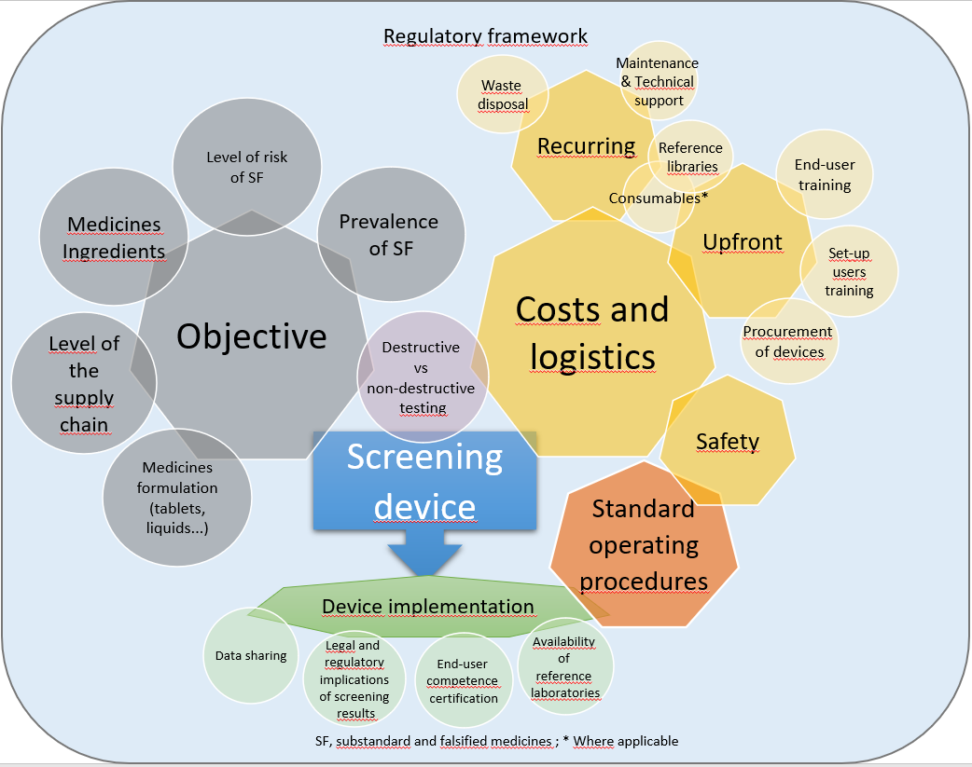
Figure 1. Major proposed considerations for the selection and implementation of medicine quality screening device.

Key findings and messages
- With the current evidence, it is unlikely that any one device would be able to effectively monitor the quality of all medicines.
- Major gaps in the scientific evidence remain which are key barriers for regulators wishing to implement them in their post-market surveillance systems and more research to improve the evidence base to guide policy is needed.

References
(1) Caillet C, Vickers S, Zambrzycki S, Luangasanatip N, Vidhamaly V, Boutsamay K, et al. (2021) Multiphase evaluation of portable medicines quality screening devices. PLoS Negl Trop Dis 15(9): e0009287. https://doi.org/10.1371/journal.pntd.0009287
(2) Zambrzycki SC, Caillet C, Vickers S, Bouza M, Donndelinger DV, Geben LC, et al. (2021) Laboratory evaluation of twelve portable devices for medicine quality screening. PLoS Negl Trop Dis 15(9): e0009360. https://doi.org/10.1371/journal.pntd.0009360
(3) Caillet C, Vickers S, Zambrzycki S, Fernández FM, Vidhamaly V, Boutsamay K, et al. (2021) A comparative field evaluation of six medicine quality screening devices in Laos. PLoS Negl Trop Dis 15(9): e0009674. https://doi.org/10.1371/journal.pntd.0009674
(4) Luangasanatip N, Khonputsa P, Caillet C, Vickers S, Zambrzycki S, Fernández FM, et al. (2021) Implementation of field detection devices for antimalarial quality screening in Lao PDR—A cost-effectiveness analysis. PLoS Negl Trop Dis 15(9): e0009539. https://doi.org/10.1371/journal.pntd.0009539
(5) Caillet C, Vickers S, Vidhamaly V, Boutsamay K, Boupha P, Zambrzycki S, et al. (2021) Evaluation of portable devices for medicine quality screening: Lessons learnt, recommendations for implementation, and future priorities. PLoS Med 18(9): e1003747. https://doi.org/10.1371/journal.pmed.1003747

