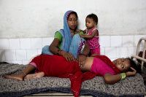





Infectious Diseases Data Observatory

Infectious diseases data observatory | www.iddo.org

**Strategic plan 2019 - 2023**

# EXECUTIVE SUMMARY

­

[**IDDO**](https://www.iddo.org/)**’s 2019-2023 Strategic Plan outlines its approach to addressing some of the world’s most pressing public health challenges. IDDO aims to expand data re-use and collaboration within the global health community to deliver better treatment and control of poverty-related infectious diseases like malaria and Ebola. Constructed under three key pillars – build, curate, innovate – IDDO will expand its proven model of evidence generation from seven to fifteen areas of work.**

**INTRODUCTION**

Launched in 2016, The Infectious Diseases Data Observatory (IDDO) is a scientifically independent, multi-disciplinary coalition of the global infectious disease community. It provides the methods, governance and infrastructure to translate data into evidence that improves outcomes for patients worldwide.

IDDO builds on and incorporates the pioneering work of the WorldWide Antimalarial Resistance Network (WWARN), a unique, decade-long collaborative data-sharing framework that proved it was possible to produce policy-changing scientific evidence from historical data, benefitting the health of millions.

##### IMPACT

WWARN has produced policy-changing evidence that has resulted in the World Health Organization (WHO) revising the recommended drug dose for children with malaria. Its outputs also identified that malnourished children have a higher risk of treatment failure, and that fixed-dose combination drug treatments are more effective than non-fixed dose.

**Vision**

A healthy future for the world’s most at risk populations, realised through global scientific partnerships.

**Mission**

IDDO accelerates better treatment and control of poverty-related infectious diseases by generating research evidence through data re-use, putting the communities most affected at the centre of its global collaborations.

**Principles**

IDDO follows the FREE FAIRER principles of ensuring that research data are Findable, Rapidly available, Ethical, Equitable, Forever, Accessible, Interoperable, Reliable, Economically viable, and Reusable.

IDDO identifies and prioritises research questions; provides tools and resources that improve the design and quality of clinical studies; standardises and pools individual-patient data; and facilitates complex meta-analyses to generate evidence on the efficacy of existing medicines, inform the development of new ones and advance understanding of disease.

IDDO shares the resulting evidence widely to inform both policymakers and future researchers globally. This continually advances knowledge and builds capacity for evidence-based practice.

##### FUTURE PLANS

At the request of the health communities working on specific infectious diseases, like the Ebola community in 2015 and the Chagas community in 2017, IDDO is adapting its proven model and developing processes for other diseases.

**Currently**, **IDDO has seven active research areas**: malaria, non-malarial febrile illness, Ebola, visceral leishmaniasis, medicine quality, Chagas and schistosomiasis/soil transmitted helminthiases (STHs). **An additional five are being scoped** for feasibility: scrub typhus, melioidosis, mycetoma, noma and typhoid. **By 2023**, **IDDO aims to add a further three** areas, including filariasis, cutaneous leishmaniasis and human African trypanosomiasis, for a total of 15. **Ebola is currently evolving into an emerging infections platform** which integrates data across outbreaks of pathogens of epidemic risk.

IDDO’s impact can be amplified by applying its proven method and existing infrastructure to other diseases, while achieving significant economies of scale. However, investment will be needed to manage larger data volumes and new global scientific collaborations to realise its huge potential.

**ABOUT IDDO**

**IDDO builds research capacity in disease-affected countries by investing in the tools and resources they need, and in skills sharing.**

Every year, malaria kills over half a million people, and over a billion are at risk of contracting at least one poverty-related infectious disease (PRID). IDDO puts researchers in the regions most at risk at the centre of scientific debate, ensuring that scientists and health policy makers are involved in the scoping, building and use of its data platforms. This approach creates sustainable global research collaborations that tackle poverty-related infectious diseases more effectively in low and middle-income countries.

IDDO’s collaborative model enables more research on vital scientific questions. It addresses critical issues such as the effects of specific treatments on very young children, pregnant women, those with multiple health problems, and poor quality medical products.

The United Nations Sustainable Development Goals (SDGs) call for an end to epidemics of the deadliest

Infectious diseases by 2030. Achieving this requires a sustained, multidisciplinary approach that draws

on knowledge and data from a broad range of partners and sectors.

**IDDO is expanding its portfolio based on a proven model.**

IDDO’s work supports the SDGs by assembling data for use by the public health, research and humanitarian communities, generating the scientific evidence that accelerates advances in safe and improved treatments for patients. By applying WWARN’s proven experience and expertise, IDDO is pioneering equitable, community-wide data sharing across a wider research portfolio of NTDs and emerging infections.

IDDO works with public health and research communities across the world and is based in the Centre for Tropical Medicine and Global Health at Oxford University.

### IDDO’s work is characterised by three strategic themes:

|  |  |  |
| --- | --- | --- |
| **1**  **BUILD**  build*| bild | verb:*  *Establish and develop over time. Construct by assembling parts to increase in size or intensity.*   * **Make science the driver** of data-sharing * **Advocate for equity** in data sharing * Cultivate **strong partnerships** as the foundation of collaboration * Secure a **sustainable future** for the IDDO network and resources | **2**  **CURATE**  cur 🢞 ate *|‘kyoo-rāt | verb:*  *Select, organise and present using expert knowledge.*   * **Assemble sparse and dispersed data** into anefficient and scalable data repository * Develop software architecture to support a **streamlined data platform** * Facilitate **access to data** * Develop, apply and promote **data standards** that improve the efficiency and quality of data and evidence | **3**  **INNOVATE**  In 🢞 no 🢞 vate *| ‘in∂,vāt | verb*  *Make changes by introducing new methods, products or ideas.*   * **Generate evidence** that saves lives * **Develop novel tools** that support sustainable development of better research * Establish **more accurate and efficient research designs and methods** |

# OUR IMPACT

THE IDDO MODEL

### A multidisciplinary, multi-infectious disease data repository and scientific network are just two parts of how IDDO shapes the research landscape.

IDDO protects the long-term security and availability of data by storing data in its repository so that can be used in multiple secondary analyses, years or even decades after primary collection. In the field of poverty-related infectious diseases, data are scarce and scattered across institutions around the world. In partnership with research communities working on the front line, IDDO assembles the limited data on a centralised data platform.

Using existing data to fill knowledge gaps saves time, reduces costs, removes the need to recruit new populations into additional studies and increases the evidence base on populations under-represented in individual studies. This has the potential to reduce health disparities. The data repository is just part of the wider IDDO infrastructure which includes scientific networks, technical and governance infrastructure, standards development and advocacy for evidence-based treatment.

### IDDO’s work advances knowledge.

IDDO works with research communities to identify and prioritise research questions, and provides tools and resources that improve the design and quality of clinical studies. IDDO standardises and pools data, and facilitates complex individual patient data (IPD) meta-analyses to generate evidence on the efficacy of existing medicines and inform the development of new ones. The evidence generated is widely disseminated to inform policy and future research, altogether forming a virtuous circle that enables the continual advancement of knowledge. Our partnership approach develops research capacity in low- and middle-income countries. This ensures that expert communities continue to grow where the diseases are prevalent and that they can both contribute and gain immediate benefit from global research efforts.

IDDO, in collaboration with the research community

Researchers and policy makers

**THE PROBLEM**

* Poverty-related infectious diseases affect one billion of the world’s most vulnerable citizens.
* Health inequity is compounded by poverty and lack of access to resources. IDDO’s role is to address data collection and research in a coordinated collaboration.

**OUR SOLUTION**

* An innovative data platform that collates and standardises disparate data to generate reliable evidence.
* A global framework and partnerships that promote equity, build research capacity, influence policy and health strategies based on best practices and world-class science.

**THE OUTCOME**

* Wide-scale collaboration to produce new evidence on better treatment and control of poverty-related infectious diseases.

**EVIDENCE CYCLE FOR HEALTH IMPACT**

### IDDO’s approach can be applied to multiple diseases, driving progress toward the Sustainable Development Goals.

Our work supports the delivery of several of the Sustainable Development Goals (SDGs). Good health and well-being (SDG 3) is at the heart of IDDO’s mission, and our focus on poverty-related infectious diseases helps to reduce inequality (SDG 10). IDDO is helping to enhance scientific research in developing countries (SDG 9) and is founded on the building of partnerships with relevant individuals and organisations in the scientific, public health and affected communities (SDG 17).





**United Nations Sustainable Development Goals**

BUILDING ON SUCCESS

### IDDO uses proven research approaches to tackle new themes.

Researchers collect and analyse data to advance health knowledge and solutions. The health impact of research can increase when data are made available to other researchers to do new analyses.

This approach has succeeded on diseases prevalent in high-income countries, such as cancer, diabetes and heart disease, but such initiatives on diseases affecting the world’s most at risk populations are scarce and resources are limited. This reflects the lack of commercial interest and spread of few actors in multiple countries. These challenges are compounded by the complexity of securing equitable global collaboration and the challenges of integrating many different types of data to undertake effective pooled IPD meta-analysis.

### IDDO’s success is demonstrated by WWARN’s achievements and innovative activities.

**Pioneers in data sharing in the field of malaria**

WWARN pioneered a unique inclusive approach to data sharing and analysis, at a time when data sharing was not widely practiced and well before it became a requirement by many research funders. This has resulted in the development of a successful model that has been refined over a period of 10 years. IDDO is now applying this same model to a broader range of poverty-related infectious diseases. This includes the launch of the first Ebola data platform, and the development and dissemination of standards, tools, reference materials and proficiency testing programmes that enhance prospective data collection.

**A broad range of global partnerships**

IDDO works in partnership with individual researchers, funders, academic institutions, networks, non-governmental organisations, pharmaceutical companies and product development partnerships. For instance, in 2018 IDDO collaborated with 20 partner organisations to deliver the first ever multidisciplinary international academic conference on the quality of medical products, an issue particularly affecting low- and middle-income countries.

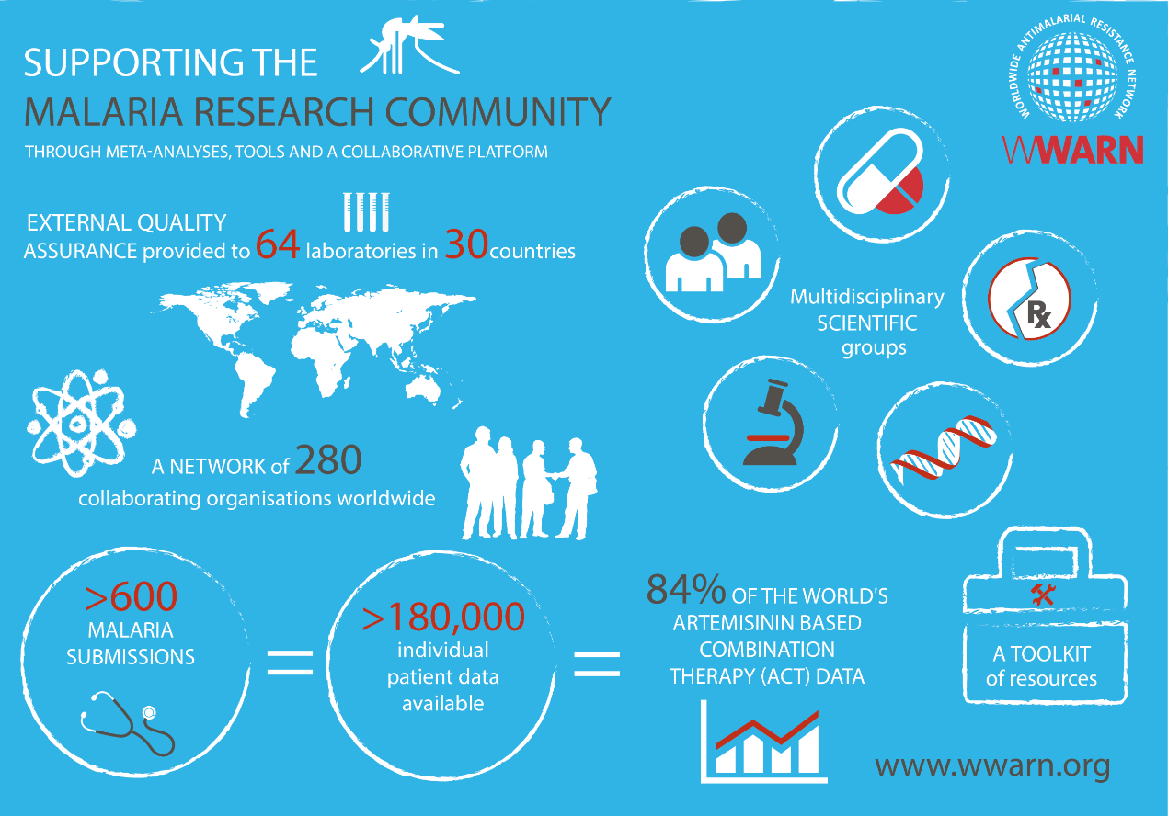

WWARN’s pioneering collaborative multidisciplinary approach to data sharing and analysis has now compiled most of the antimalarial combination therapy data published since 2000.

**Changes in Policy**

IDDO has developed a range of tools and resources, including reviews and visualisations of published literature, to enable researchers and policy makers to easily access the latest available information and identify gaps in knowledge.

**Evidence cycle for health impact**

WWARN’s innovative approach has enabled the malaria community to ask practical, life-saving research questions using individual patient data meta-analyses and cross-disciplinary analyses to identify and understand common trends. Results have been used to inform treatment guidelines and the development of generic antimalarial medicines.

For example, based on our work:

**The World Health Organisation (WHO) revised the recommended dose of DP for young children based on WWARN evidence.** The results from the WWARN Dihydroartemisinin-Piperaquine (DP) Dose Impact Study Group and pharmacometric modelling of piperaquine showed that young children with uncomplicated malaria were much more likely to fail DP treatment as a result of receiving a sub-optimal dose.





WWARN has also found that:

**Combination therapies are more effective**

* providing artemisinin and amodiaquine as a combination therapy (AS-AQ fixed dose) is more effective than treating people with separate pills of the same formulation *(see above)*;

**Malnourished children have a higher risk of treatment failure**

* artemether-lumefantrine (AL) is highly effective but malnourished children are at a higher risk of treatment failure than those who are well-nourished *(see below)*.



# OUR FUTURE

EXPANDING OUR REACH

### IDDO aims to increase its portfolio of research themes over the next five years.

**Currently,** IDDO is active in **seven** research areas; malaria, Ebola, visceral leishmaniasis, non-malaria febrile illness, medicine quality, Chagas and Schistosomiasis/Soil Transmitted Helminths (STH’s), with another five being scoped for feasibility.

**By 2021**, IDDO aims to complete the scoping and development of all currently initiated themes, resulting in **12** active research themes. **By 2023**, IDDO aims to add a further **three** research themes to this portfolio, totalling **15** themes in the IDDO data platform.

Proposals to launch new research themes originate from those in, or working with, disease endemic research communities. IDDO focuses on diseases targeted in the WHO list of neglected tropical diseases, the WHO list of priority pathogens with epidemic and pandemic potential. This community-driven process, with early engagement of advocates in the community, is one of the key steps in delivering a successful platform.

The disease community-driven requests have motivated the development of a process for assessing and selecting new opportunities. IDDO now considers the initiation of a new research theme using a set of **core criteria**, with final decisions made by the IDDO Board.

A systematic literature review and formal stakeholder analysis is undertaken for a proposed theme to be considered by the IDDO Board to meet the ‘**scoping**’ criteria. The results of the scoping are then considered against the same criteria to decide if a theme will be ‘**built**’ into the IDDO data platform. A platform is considered ‘**active**’ when the technical infrastructure, including software systems and governance, for data sharing is in place and available for use by the community.

**CORE CRITERIA FOR ASSESSING NEW RESEARCH THEMES**

**Scientific and public health relevance**: What unresolved research questions can be answered by assembling the data and what is the potential impact?

**Added value**:

What is IDDO uniquely equipped to add? Does it fit the IDDO strategy? What are the opportunity costs for IDDO?

**Partnerships and funding:**

Are the key partners engaged and supportive? Is funding available?

In addition to these core criteria, IDDO also takes into account the technical and political feasibilityincluding:

* The quantity, homogeneity and quality of available data;
* The potential for scientific impact beyond the research questions including: developing a research agenda; standardising data collection and research methodology; and characterising and addressing resistance when relevant;
* The importance of the disease within the health priorities of the affected countries.
* Links to existing IDDO community members or platforms which could accelerate the science.

IDDO is committed to focus on capacity strengthening and development of regional offices in disease-affected countries to ensure that scientists and health policy makers are involved in the scoping, building and use of the IDDO data platform where diseases are prevalent.

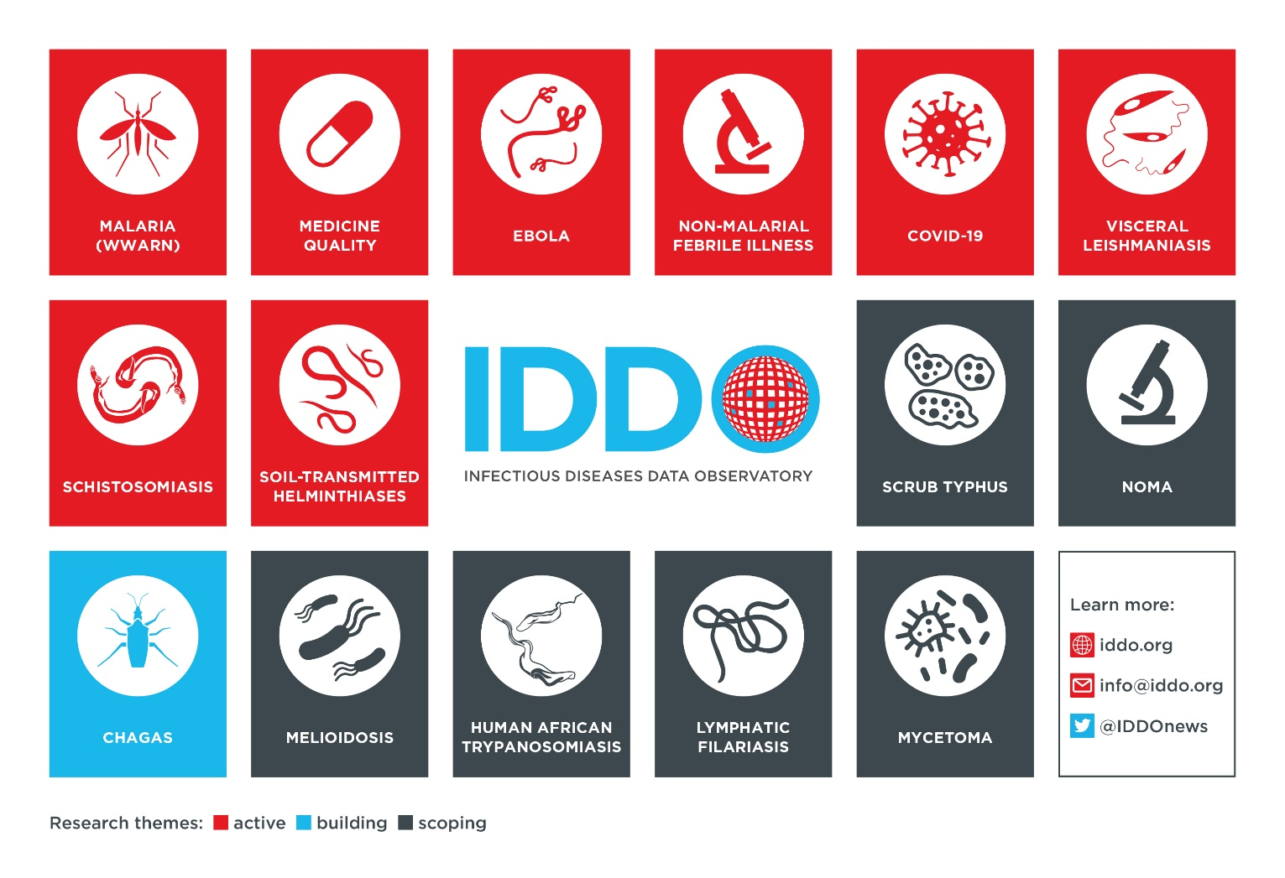

SUPPORTING OUR VISION

### A diversity of funding sources helps IDDO to remain sustainable.

A diversity in funding sources has been an ongoing challenge and a key element of IDDO’s sustainability to date, helping to ensure quality and continuity of output.

The WWARN malaria data platform was originally funded entirely by a visionary grant from the Bill & Melinda Gates Foundation (BMGF) awarded in 2009. As of January 2019, when this strategic plan was launched, IDDO & WWARN have been supported by a diverse portfolio of grants from more than 12 international funders and approach to match the needs of diverse patient and research communities with the interests of funders. IDDO aims to continue to work closely with each of these groups to pursue targeted funding for diseases of neglected interest.

However, given the number of applications,

procedures and reporting, this fragmentation in funding has an opportunity cost. Therefore we seek support for IDDO’s core team of global experts including data managers, statisticians, programmers and scientists to ensure sustainability.

### IDDO depends on visionary partners to support its core activities and new priority diseases.

Significant economies of scale can be achieved by adapting existing infrastructure for new diseases. Investment in IDDO’s core technical and governance framework will be required to realise its enormous potential for efficiency and impact. Sourcing support for core infrastructure is a key aim of this next period. IDDO will seek investment which brings collective advantage to all of the targeted patient and research communities and can be used for other poverty-related infectious diseases.

ACHIEVING OUR GOALS

Our three strategic themes – **build, curate, innovate** – are core to delivering the IDDO mission. They demonstrate the expansion of IDDO’s role in reducing the impact of poverty-related infectious diseases by optimising the evidence for their effective management; they also establish a framework for wide-scale collaboration and capacity strengthening across key partner institutions to promote equity and improve research standards globally.

|  |  |  |
| --- | --- | --- |
| **BUILD** | **Objectives** | **Activities** |
| **Make science the driver** of all data-sharing activity | * Focus on diseases and data that **impact the health of the world’s poorest and most at risk populations** starting with the WHO Neglected Tropical Diseases list and the WHO R&D Blueprint priority diseases. * Advocate globally for **purpose-driven data sharing** in diseases of priority to LMICs. |
| **Define research agendas** that prioritise the most critical evidence gaps | * Work with research communities to **assemble current evidence and define knowledge gaps** of public health importance. * **Define prioritised, consensus-driven research agendas for each disease** together with stakeholders from the patient, clinical, research and policy communities. |
| **Advocate for equity** in data sharing | * Continue to **develop and refine transparent governance standards** across research themes. * **Support scientific leadership and ownership** of the research themes in endemic countries, e.g. decentralise data curation, communications and scientific analyses to partners in endemic countries. |
| Cultivate **strong partnerships** as the foundation of collaboration | * **Formalise partnerships with regional and global health organisations and networks** that share IDDO’s vision, e.g. WHO * Ensure **equity in collaboration** by building on existing research capacity in disease-affected countries through investment in user-prioritised **tools and resources, skills sharing and mentorship.** * Build trust through **transparent communication and robust governance**. |
| Secure a **sustainable future** for the IDDO network and resources | * Maintain a **diverse funding portfolio** which meets the needs of the research communities. Continually consider relevant new opportunities and **support proposals led by researchers in endemic countries**. * **Pursue support to underpin technical infrastructure and core team of global experts**. |

|  |  |  |
| --- | --- | --- |
| **CURATE** | **Objectives** | **Activities** |
| **Assemble sparse and dispersed data** into an efficient and scalable data repository | * **Integrate individual patient datasets** into an accessible, harmonised, multi-disciplinary global resource available for immediate and long-term use. * Refine and accelerate **approaches to data curation** using novel methods. |
| Develop software architecture to support a **streamlined data platform** | * Develop and apply **novel software architecture** for interdisciplinary data integration and interoperability enabling the harmonisation of divergent datasets for cross-disciplinary analyses. |
| **Facilitate data access with shared data** | * Through our **Data Access Committee** make more data available for secondary analyses to produce more evidence. |
| Develop, apply and promote data standards that **improve the efficiency and quality of data and evidence** | * Contribute to the **expansion of clinical data standards**, ensuring that all IDDO data follow international best practice, e.g. expand Clinical Data Interchange Standard Consortium (CDISC) terminology to all IDDO diseases. * Configure and enhance data systems to integrate standards into data collection and tabulation, thus improving the efficiency and quality of research, e.g. make CDISC-compliant data capture forms and tools available to the research community. |

|  |  |  |
| --- | --- | --- |
| **INNOVATE** | **Objectives** | **Activities** |
| **Generate evidence** that saves lives | * **Decrease the time, cost and barriers** to secondary data analysis. * **Generate evidence** that cannot be drawn from individual primary research studies. * **Disseminate evidence** to the health communities where it can have the greatest impact. |
| **Develop novel tools** that support sustainable development of better research | * Develop and disseminate tools that apply **evidence-based approaches** to best practice in research methods. * Support the uptake of tools across disease-affected countries through **training, skills sharing and mentorship**. |
| Establish more **accurate and efficient research designs and methods** | * Leverage the IDDO platform to compare research designs and determine the **most efficient and robust methods** to conduct individual patient data meta-analysis. * Assemble information to **develop spatial and temporal models**, e.g. mapping complex outcomes, observing trends, developing prognostic models. |



TOWARDS 2023

IDDO’s goals are ambitious. However, they are based on the extension of a proven model, trusted across a number of research communities to optimise the equitable use of existing data to deliver innovative, evidence-based science.

These goals can be achieved through close collaboration with the respective disease communities, and the support of funders and partners who share our vision for effective treatment and controlof infectious diseases affecting the most at risk populations. A truly collaborative effort will enable us to inform future treatment and control policies and the development of new drugs for a range of diseases.

**By 2023, the global IDDO community will have played an important part in progressing towards the delivery of the Sustainable Development Goals.**

Image credits: Drugs for Neglected Diseases *initiative*/ IDDO/ Mehul Dhorda/ Richard Cooksey