Measuring respiratory rate v2.0

Procedure

WorldWide Antimalarial Resistance Network (WWARN)
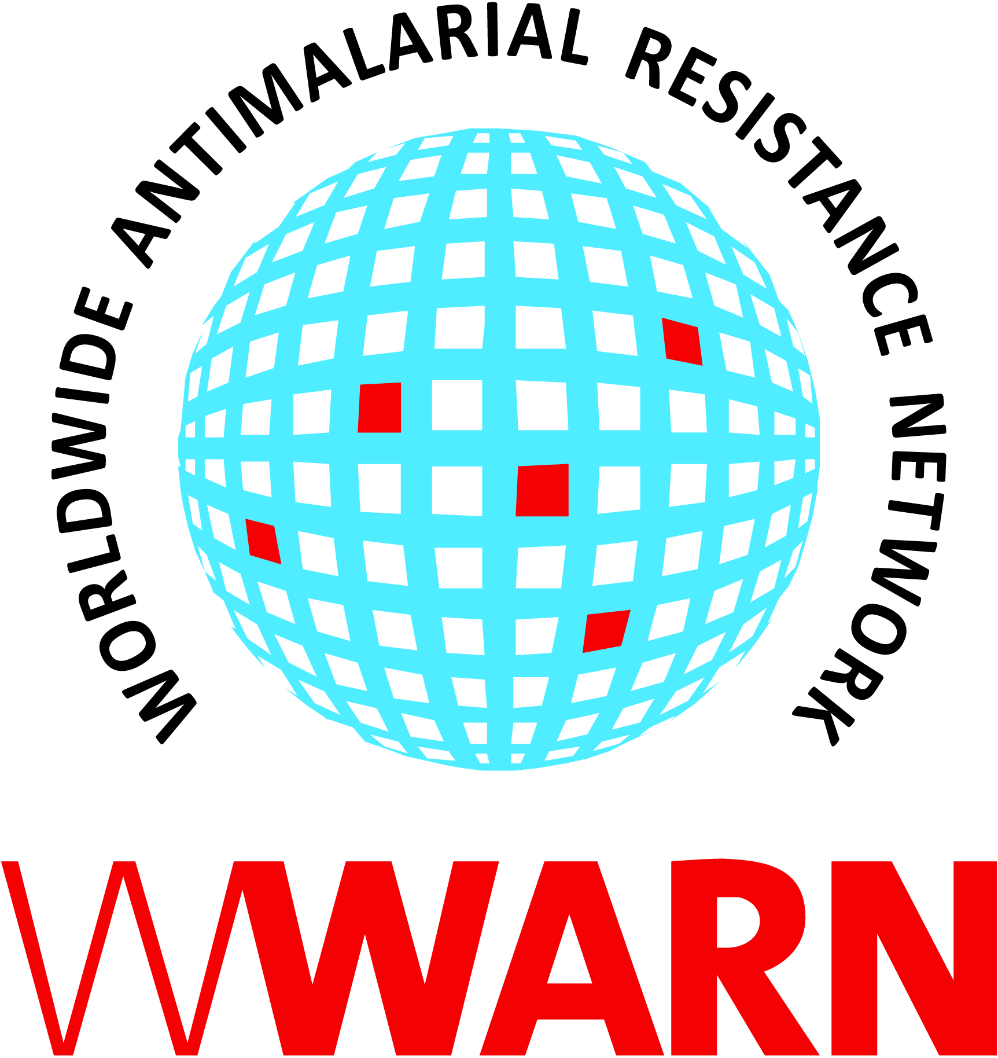

Suggested citation: WWARN Procedure. Measuring respiratory rate v2.0

Procedure ID: CL05
This procedure was developed by: WWARN who gratefully acknowledge the contribution of Grant Dorsey (University of California, San Francisco) and Epicentre/MSF (Médecins Sans Frontier) Paris, France

Version History
Version number | Revision(s) & reason for amendment | Release Date
1.0 | Creation of procedure | 03Jan2012
2.0 | Updated nomenclature, other minor administrative changes | 14Sep2018

For more information, contact:
info@wwarn.org

WorldWide Antimalarial Resistance Network (WWARN) www.wwarn.org

Contents

1. Purpose/scope 4
2. Abbreviations 4
3. Definitions 4
4. Associated forms 4
5. Duties and responsibilities 4
5.1 Tasks 4
5.2 Materials and equipment 4
6. Procedures 4
6.1 Measuring RR in older children and adults 4
6.2 Measuring RR in children 5
6.3 Maximum acceptable values 5
7. References 5

1. Purpose/scope
The purpose of this document is to describe a standardised procedure for measuring and recording respiratory rate (RR) in patients enrolled in an antimalarial drug efficacy trial. This procedure is intended for use in clinical trials where patients are attending a clinic for antimalarial treatment. Accurate assessment and measurement of respiration is an important part of a clinical evaluation. Respiratory distress is a manifestation of severe disease and poor prognosis in some children with malaria.

2. Abbreviations
CRF Case Record Form

RR Respiratory Rate

3. Definitions
RR Number of respiratory excursions per minute
Respiratory excursion A full in- and out-breath

4. Associated forms
None

5. Duties and responsibilities

5.1 Tasks
Tasks can be assigned to individual(s) capable of their execution and their name entered beside the task listed in the table below and/or as recorded on a delegation of responsibilities/tasks documentation:

Study personnel
Measure RR of patients
Record the RR of patients

5.2 Materials and equipment
- Watch or clock measuring seconds
- CRF

6. Procedures

6.1 Measuring RR in older children and adults
- If necessary, the patient should be instructed to remove bulky or loose clothing.
- The patient should be seated facing the observer so that the face and movements of the chest wall can be easily observed.
- Respiratory excursions should be observed, and the time noted before counting the number of excursions for 30 seconds using a clock or watch measuring seconds. Count for a full 30 seconds. Do not count excursions for a shorter time since this is less accurate.
- Rather than relying solely on visual assessment of respiratory excursions, it is easier and more accurate to count respirations by placing one’s hands on the chest wall and feeling its movements. This allows the study personnel to watch the time and count respiratory excursions at the same time. This method is also useful in counting respirations if the subject is lying in bed.
- Multiply by 2 the number of excursions in 30 seconds to get the RR per minute.

6.2 Measuring respiratory rate in children
The RR in children has a greater range and is more responsive to illness, exercise and emotion than in adults. In infancy and childhood, diaphragmatic breathing is predominant and thoracic excursion is minimal. To measure the RR in children:
- Observe abdominal rather than chest excursions. Using a stethoscope to listen to the chest or placing the stethoscope in front of the mouth and nostrils are also useful techniques for counting respirations in this age group.
- Note the time and start counting the number of respirations for 30 seconds beginning at the end of expiration. Count for a full 30 seconds. Do not count excursions for a shorter time since this is less accurate. Multiply by 2 the number of excursions in 30 seconds to get the RR per minute.

6.3 Maximum acceptable values
To establish whether a patient’s respirations are within normal limits, consult the table below:
Age | Maximum acceptable value  (RR/min)
< 2 months | 60
2-5 months | 50
5-14 years | 40
> 14 years | 32

7. References
WHO (2000), Severe Falciparum Malaria, World Health Organization, Communicable Diseases Cluster. Trans R Soc Trop Med Hyg 94 Suppl 1: s1-90

