Management of hyperparasitaemia v1.0

Procedure

WorldWide Antimalarial Resistance Network (WWARN)
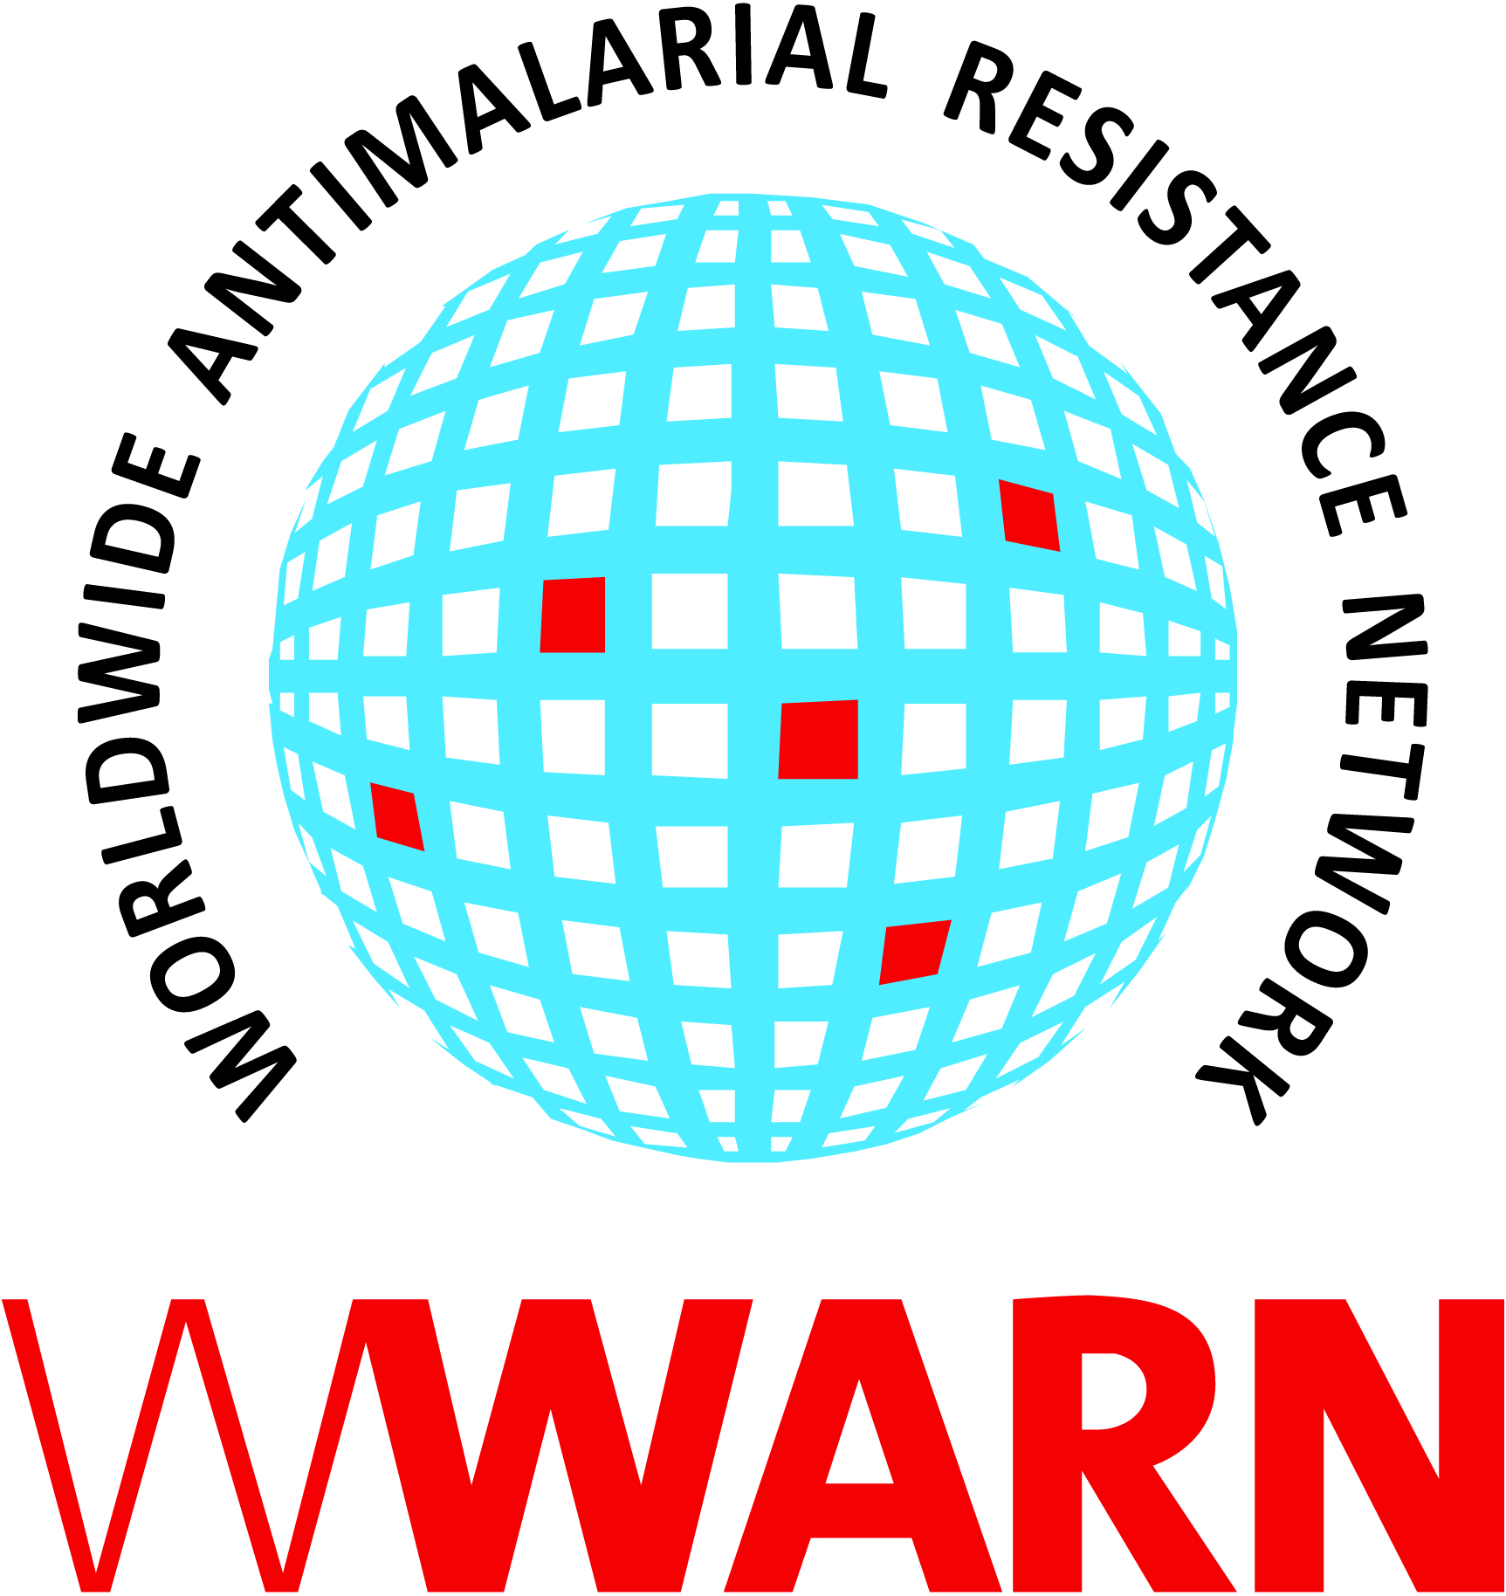

Suggested citation: WWARN Procedure. Management of hyperparasitaemia v1.0

Procedure ID: CL06
This procedure was developed by:

The Collaborating Centre for Optimising Antimalarial Therapy (CCOAT), Division of Clinical Pharmacology, Department of Medicine, University of Cape Town, Cape Town, South Africa

Version History
Version number | Revision(s) & reason for amendment | Release Date
1.0 | Creation of procedure | 14Sep2018

For more information, contact:
info@wwarn.org

WorldWide Antimalarial Resistance Network (WWARN) www.wwarn.org

Contents

1. Purpose/scope 4
2. Abbreviations 4
3. Definitions 4
4. Associated forms 4
5. Procedure 4
6. References 5

1. Purpose/scope
Patients with uncomplicated hyperparsitaemia are at increased risk of treatment failure, severe malaria and death. Routine case management and field studies generally diagnose malaria based on rapid diagnostic tests that can only differentiate between positive and negative results and cannot quantify parasite density. Thus, microscopy of thick and thin smears should be performed as soon as possible by a qualified microscopist to determine parasite density, and patients with uncomplicated parasitaemia should be monitored more closely. This procedure describes the process for case management of patients with uncomplicated hyperparasitaemia in field studies, particularly for sites without resident microscopy facilities or a medical doctor and applies to all clinical staff who monitor participants’ parasite status during a trial. The roles of staff will depend on the trial and site set-up.

2. Abbreviations
AE Adverse Event
ISF Investigator Site File
PI Principal Investigator
RBC Red Blood Cell
SAE Serious Adverse Event

3. Definitions
Uncomplicated hyperparasitaemia
Parasite density of ≥2% RBCs infected with asexual P. falciparum parasites in patients without any signs or symptoms of severe malaria, i.e. no signs of vital organ dysfunction

4. Associated forms
None

5. Procedure
- The microscopist should inform the site by telephone as soon as any smear is found to have a parasite density greater than or equal to 2% (or 100 000 asexual parasites per microliter)
- The investigator (or designee) should contact the patient (or guardian) immediately to explain that they have a lot of malaria parasites, so it is especially important that they:
  - Take all the malaria tablets as prescribed with food,
  - Come for all their follow up visits as scheduled, and to arrive as early as possible in the morning
  - And let the clinic know if they are unwell in anyway.
- The investigator (or designee) should perform an extra thorough and careful clinical assessment at the next visit to ensure no malaria complications are missed, with reference to danger signs and clinical features of severe malaria (as per current guidelines provided to the site)
- The microscopist should make every effort to have Day 3 smears of hyperparasitaemic patients stained and read on the same day
- The Principal Investigator (PI) will be kept informed of the status of all patients with high parasite densities throughout the above process and of results from subsequent follow-up visits (parasitological and clinical) so that appropriate steps are taken about how the participant is managed medically and as regards the trial
- A detailed record of attempts to follow up the above patients, including communications by phone or via case investigators, or information recorded at visits, will be kept in the medical notes. Any decisions taken by the team should also be documented for the ISF and appropriate forms completed for cases of trial withdrawal/AE or SAE. The microscopist(s) will also keep accurate records of smear results in the trial-specific log as per training provided

6. References
None

