Management of acute haemolysis (primaquine for P vivax) v1.0

Procedure

WorldWide Antimalarial Resistance Network (WWARN)
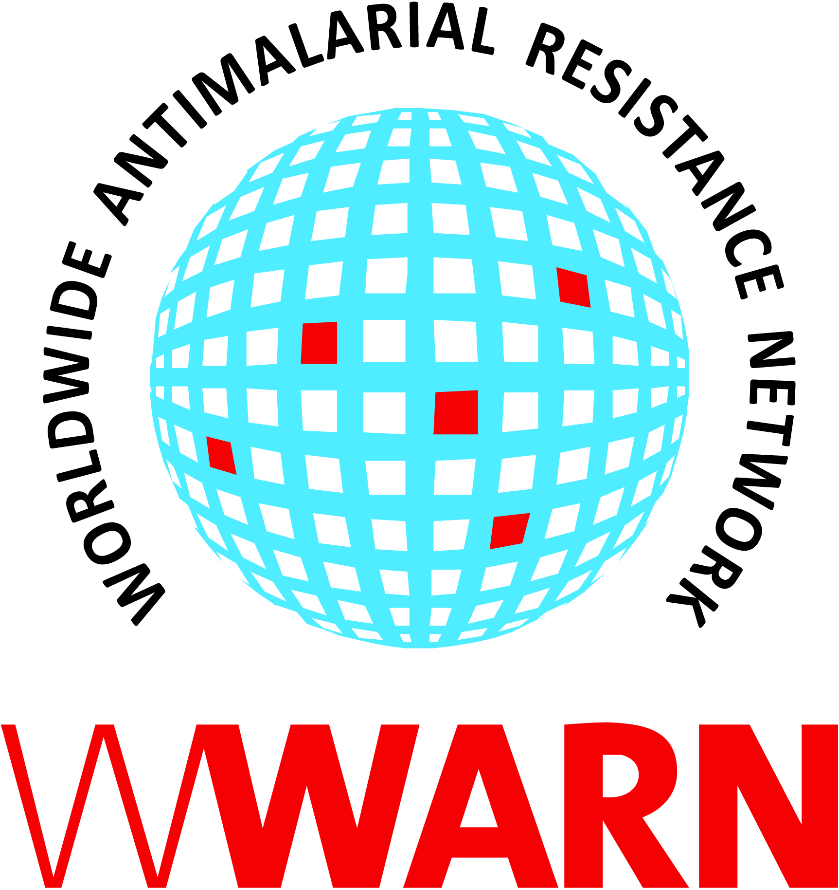

Suggested citation: WWARN Procedure. Management of acute haemolysis (primaquine for P vivax) v1.0

Procedure ID: CL08
This procedure was developed by: The IMPROV Study Group (Drs Bob Taylor, Ric Price)

Version History
Version number | Revision(s) & reason for amendment | Release Date
1.0 | Creation of procedure | 14Sep2018

For more information, contact:
info@wwarn.org

WorldWide Antimalarial Resistance Network (WWARN) www.wwarn.org

Contents

1. Introduction 4
2. Background 4
3. Identification of acute haemolysis 4
4. Definitions 5
5. Acute clinical management 5
6. Subsequent clinical management 6
7. Further guidelines for the management of patients with a haemolytic SAE 6
8. Additional study requirements 7
Adverse event 7
Serious adverse event 8
9. References 8

1. Introduction
This procedure outlines an approach to managing suspected haemolysis in participants taking part in trials using primaquine for P vivax infection. Two annexes contain additional information on the symptoms, signs and investigation of anaemia and drugs that can cause haemolysis or interact with primaquine. The clinical judgement of the attending clinician and patient safety should always come first, regardless of the trial protocol. Each site varies in capacity; hence management and interventions should be adapted to local clinical practice.

See Procedure CL09 for management of acute haemolysis in trials using low-dose primaquine, where the risk is lower (and may be conducted in field trials with less clinical expertise on-site).

2. Background

Haemolysis in acute malaria is inevitable, the mean haemoglobin concentration usually falling within the first week, with recovery usually taking 28-42 days. The use of primaquine in patients with P. vivax infection can cause additional haemolysis particularly in patients with glucose-6-phosphate dehydrogenase (G6PD) deficiency; the predominant mechanism for this is intravascular haemolysis. Clinicians need to be vigilant for the signs and symptoms of haemolysis and the risk of trial subjects becoming anaemic. Severe haemolysis and anaemia is likely to result from a variety of factors, including: the severity of G6PD enzymatic deficiency, the dose of primaquine, the degree of parasitaemia and nutritional status.

3. Identification of acute haemolysis
At each clinical encounter the clinician should exclude the possibility of significant haemolysis. This includes:
- Detailed history and examination: including a history of dark urine, jaundice, breathlessness and other symptoms of anaemia (see Annex 1). A full drug history should be taken looking for the use of drugs and herbal remedies that can cause haemolysis or interact with primaquine (see Annex 2).
- HemoCue® haemoglobin measurement: this should be compared against previous haemoglobin results, particularly the baseline value prior to starting primaquine, to gauge the degree and speed of decline.
- Hillmen urine colour estimation for haemoglobinuria: urine should be placed in a clear glass container and held up against a white piece of paper, in a well illuminated area, before estimating the colour compared to the Hillmen Colour Chart (a colour version should be provided to the site). Urine colour estimation should be carried out as soon after voiding as possible. A score of 5 or above is considered evidence of haemoglobinuria.
- Repeat G6PD fluorescent spot test: if on the basis of clinical assessment, haemoglobin measurement and urine colour assessment for haemoglobinuria, it is considered that haemolysis may be occurring. All patients with normal G6PD should have a repeat G6PD fluorescent spot test to confirm this.
- Intensive review: any concern should prompt increased frequency of review or admission to hospital for monitoring at the discretion of the attending clinician. Based on this assessment, patients should be categorised into: i) those in whom there is currently no major concern for haemolysis. ii) those who have indicators of clinical concern but who do not constitute severe haemolysis iii) those with severe haemolysis or anaemia

4. Definitions
Any one of the following defines a haemolytic Serious Adverse Event (SAE):
1. Haemoglobin of < 7g/dL OR
2. Anyone requiring a blood transfusion OR
3. Macroscopic haemoglobinuria (Hillmen ≥ 5) PLUS a fractional drop in haemoglobin ≥ 25% from baseline

Warning signs (patient does not fulfil criteria for SAE but has at least one of the following):
1. Macroscopic haemoglobinuria (Hillmen ≥ 5) OR
2. Fractional haemoglobin fall ≥ 25% vs. baseline at randomisation OR
3. Significant clinical concern with regard to anaemia or haemolysis assessed by the attending clinician.

5. Acute clinical management
Initial management
• Patients should be assessed clinically by the attending clinician, and
• Subsequent primaquine/placebo doses should be withheld pending further review

Further management
All patients with a haemolytic SAE or warning signs must be have close clinical monitoring including:
• A daily clinical review
• Daily haemoglobin measurement until evidence of haemoglobin recovery
• Daily Hillmen urine colour estimation.
• Additional more frequent review and/or admission to hospital, as indicated
• Repeat G6PD testing
• The trial coordination team should be informed as early as possible.

At each review, a decision must be made to:
• Continue to withhold primaquine/placebo or
• Re-dose primaquine/placebo or
• Stop primaquine/placebo completely

The decision to retreat subsequent P. vivax infections with primaquine in patients who have experienced an episode of acute haemolysis, is at the discretion of the attending clinician unless otherwise indicated in the protocol. Patients who have had an episode of severe acute haemolysis related to primaquine use, are at significant risk of further haemolysis on reexposure to primaquine or other medications causing oxidative stress. Hence the decision to redose should be made after assessing the risks and benefits and discussing these with the patient/guardian. The following are suggested guidelines:
- If the haemoglobin falls by ≥ 1 g/dL in the preceding 24 hours: primaquine/ placebo should continue to be withheld and the patient continued to be reviewed closely.
- If the haemoglobin is stable or falls by < 1 g/dL in the preceding 24 hours: the patient can be re-dosed with primaquine/placebo, at the discretion of the attending clinician. Further daily monitoring should be undertaken for at least 3 days. Patients should continue as per protocol to complete 12 months of follow up.
- If the patient has clinical decompensation associated with recent primaquine use and/or anaemia: then the patient should be admitted to hospital for blood transfusion. The current primaquine/placebo regimen should be stopped and the need for unblinding should be discussed with the trial coordination team.

Repeat G6PD testing
Patients with normal G6PD and a haemolytic SAE or warning signs should have their G6PD status rechecked immediately. Samples should be taken prior to blood transfusion (since transfusion can mask G6PD deficiency) as well as 6 weeks after the resolution of the severe acute haemolysis (or 12 weeks after the receipt of a blood transfusion).

6. Subsequent clinical management

Patients without clinical compensation who restarted their primaquine/placebo treatment without further deterioration should complete their primaquine/placebo and continue in the study as per the study schedule. If the patient’s primaquine/placebo regimen is stopped, then referral should be made to the Bangkok coordinating team to discuss unblinding. All patients should be encouraged to remain in the study and continue to be followed up, including those patients who have been unblinded. The follow up period remains the same i.e. one year after the first dose of study drug was given. Continue to fill in the usual case record forms. If patients develop subsequent symptomatic recurrent P. vivax parasitaemia, they should be treated with chloroquine or artemisinin-based combination therapy (ACT) (unless as indicated in the protocol) and considered for primaquine regimen on a case by case basis as per local recommendations.

7. Further guidelines for the management of patients with a haemolytic SAE
Patients with a haemolytic SAE and clinical decompensation should be admitted to a hospital with a blood transfusion service and managed according to local protocols.

The key principles of managing acute drug-induced haemolysis include the following:
- Stopping all drugs known to cause haemolysis
- Comprehensive clinical evaluation and intensive monitoring, including vital signs, fluid balance and frequent assessment for haemoglobinuria
- Monitoring of haemoglobin and renal function
- Blood transfusion if indicated

It is recognised that blood transfusion protocols and practices vary between different sites. The following are offered as suggested indications for transfusion:

Haemoglobin < 7 g/dL and clinical decompensation due to anaemia:
• Breathless at rest
• Breathlessness on exertion over a short distance
• Severe fatigue/lethargy/dizziness
• Prostration
• Signs of cardiac failure
• Cardiac chest pain

Additional Investigations
In addition to clinical samples taken for the acute management of haemolysis, the following samples should be taken if possible from patients with severe acute haemolysis for the investigation of the factors contributing to haemolysis:

- 1 x 5ml EDTA blood tubes: for full blood count (2ml), Coomb’s (direct agglutination test) (1ml), further G6PD testing, other enzymopathies (metHb reductase, glutathione reductase and pyruvate kinase deficiency).; 500ul whole blood should be stored at -20°C for genotyping, 1.5ml stored at -80°C in glycerol-based protocol quantitative assay of G6PD and other enzyme activities.

- 1 x 5ml Lithium heparin blood tube: (1ml) Na+ , K+ , creatinine, urea, LDH, AST, ALT, total & free / unconjugated bilirubin, (1ml) haptoglobin and cell free haemoglobin concentration (-20°C), (1ml) primaquine, carboxyprimaquine and chloroquine drug concentrations (frozen at -80°C), (1ml) markers of oxidative stress. (This tube should be promptly cooled after collection, centrifuged at 1500 G for 5 mins, and plasma then frozen at –80°C).

- 1 x 10ml Urine in white topped tube (no additive) container: ideally midstream urine, promptly freeze 2 x 1ml aliquots at –80°C.

8. Additional study requirements

Adverse event

An adverse event (AE) form must be filled for all patients who have their primaquine/placebo stopped for whatever reason. The following are examples of haematological AEs relevant to this procedure:

• Haemoglobin of < 7g/dL

• Requirement for a blood transfusion

• Severe haemolysis

• Clinical concern due to haemolysis

• Clinical concern due to anaemia

Add in the necessary clinical details (e.g. “The patient had macroscopic haemoglobinuria and a fall in Hb of 25% compared to baseline (Day 0 Hb 10, Day X Hb 7.5 g/dL) and felt more tired than usual” or “The patient noticed he was short of breath when walking to work and his Hb had fallen from 9.5 g/dL at baseline of Hb to 8 g/dL on Day X”).

Serious adverse event

As defined above the following are SAEs (in addition to the standard SAE criteria as per ICH):

• Haemoglobin of < 7g/dL

• Anyone requiring a blood transfusion for haemolysis

• Macroscopic haemoglobinuria (Hillmen ≥ 5) PLUS a fractional drop in haemoglobin ≥ 25% from baseline

Follow the SAE SOP for reporting the SAE within the necessary time frame.

9. References
IMPROV Study Group. Improving the radical cure of vivax malaria (IMPROV): a study protocol for a multicentre randomised, placebo-controlled comparison of short and long course primaquine regimens. BMC Infect Dis. 2015 Dec 7;15:558
Annex 1 Symptoms and signs of anaemia

Symptoms:
• Breathlessness
• Fatigue
• Faintness
• Palpitations
• Backache
• Headache
• Chest pain

Passing dark coloured urine (if haemolysis is the cause)

Physical signs:
• Tachycardia
• Tachypnoea
• Palmar and conjunctival pallor
• Systolic flow murmur
• Shock
• Signs of cardiac failure
• Dark coloured urine (if haemolysis is the cause)
• Jaundice (if haemolysis is the cause)

Laboratory features of haemolytic anaemia:
• Falling haemoglobin concentration/haematocrit
• Heinz bodies, bite cells and polychromasia on blood film
• Increasing reticulocyte count (causing mild macrocytosis)
• Increased LDH
• Increased bilirubin (unconjugated)
• Reduced haptoglobins
• Increased urinary urobilinogen
• Haemoglobinuria

Some of these symptoms and signs can be related to malaria, so a careful evaluation is essential.
Annex 2 Drugs that cause haemolysis or interact with primaquine

If patients need to be treated for an intercurrent illness potentially haemolytic drugs should be avoided in patients with G6PD deficiency. These include:
• Dapsone
• Sulphonamides
• Methylene blue
• Nalidixic acid
• Nitrofurantoin
• Niridazole
• Traditional medicines
• Ciprofloxacin, norfloxacin

The following drugs should also be avoided since these may increase the exposure of primaquine, chloroquine, piperaquine and lumefantrine metabolism by inhibiting the cytochrome (CYP) 450:
• Ketoconazole, itraconazole
• Cimetidine
• Grapefruit juice
• Erythromycin
• Ritonavir

Each study should draw up a list of drugs according to current guidelines

