Management of acute haemolysis (low dose primaquine) v1.0

Procedure

WorldWide Antimalarial Resistance Network (WWARN)
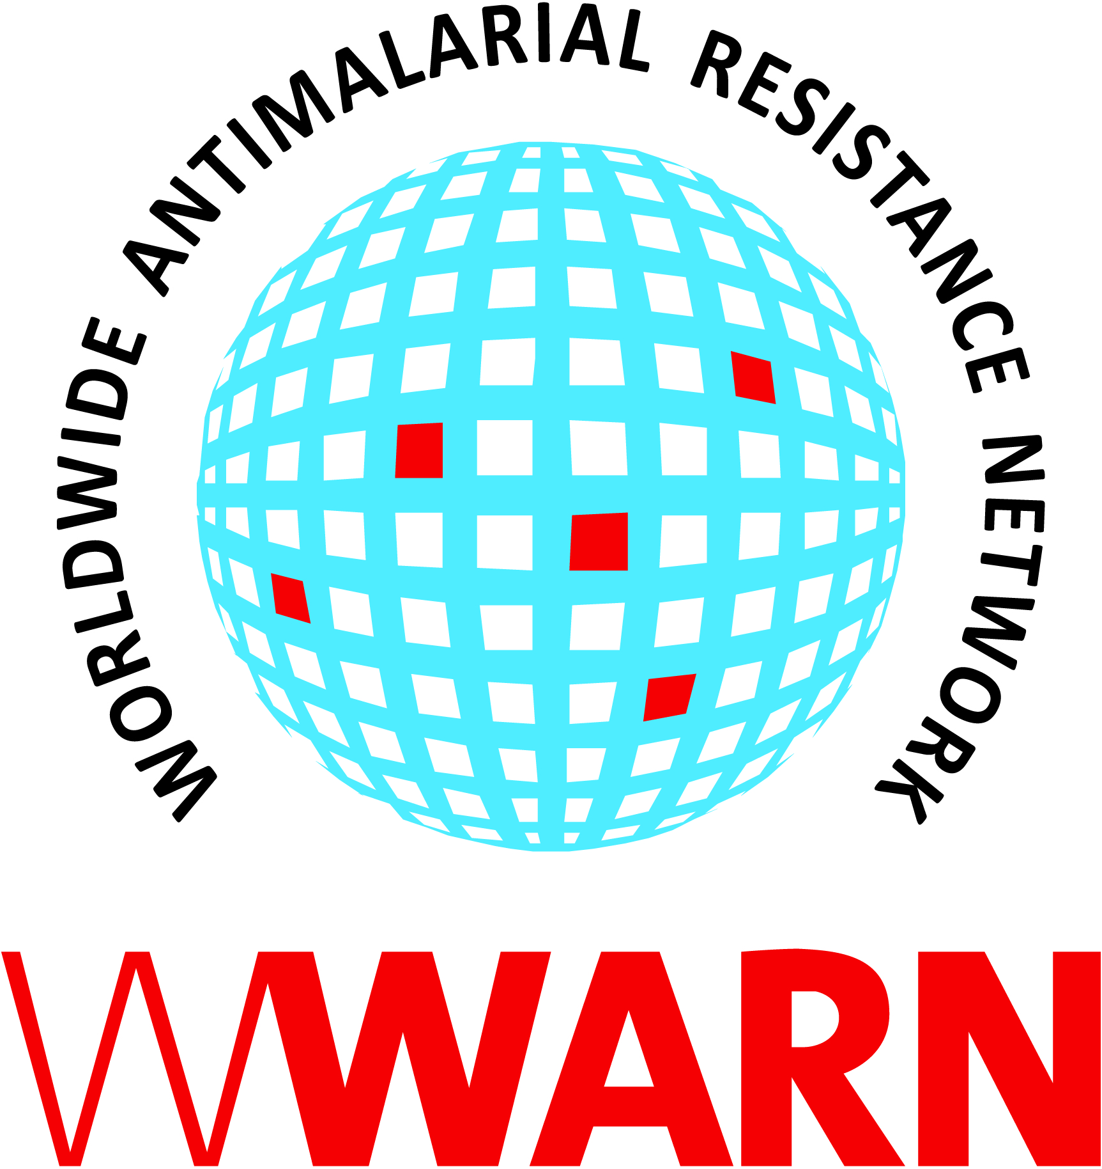

Suggested citation: WWARN Procedure. Management of acute haemolysis (low dose primaquine) v1.0

Procedure ID: CL09
This procedure was developed by:

The Collaborating Centre for Optimising Antimalarial Therapy (CCOAT), Division of Clinical Pharmacology, Department of Medicine, University of Cape Town, Cape Town, South Africa with reference to the IMPROV Study Group’s SOP for haemolysis

Version History
Version number | Revision(s) & reason for amendment | Release Date
1.0 | Creation of procedure | 14Sep2018

For more information, contact:
info@wwarn.org

WorldWide Antimalarial Resistance Network (WWARN) www.wwarn.org

Contents

1. Purpose/scope 4
2. Abbreviations 4
3. Definitions 4
4. Associated forms 4
5. Procedure 4
5.1 Identification of suspected haemolysis 4
5.2 Management of suspected haemolysis 4
5.3 Documentation 5
6. References 5

1. Purpose/scope
Haemolysis in acute malaria is inevitable, the mean haemoglobin concentration usually falling within the first week, with recovery usually taking 28-42 days. The use of low dose primaquine in patients with P falciparum infection for transmission blocking can cause additional haemolysis, particularly in patients with glucose-6-phosphate dehydrogenase (G6PD) deficiency. Therefore, clinical staff need to be vigilant for the signs and symptoms of haemolysis and the risk of trial subjects becoming anaemic. This procedure describes a simplified process for field site staff to identify and manage any cases of suspected acute haemolysis in a clinical trial involving low-dose primaquine. This procedure has been adapted from the IMPROV Study Group’s procedure and applies to study team members responsible for preparing for conduct of a new clinical trial. See Procedure CL08 for guidance for the management of acute haemolysis in those taking part in trials with primaquine for the treatment of P Vivax (which will be at a higher dose than for low-dose primaquine).

2. Abbreviations
AE Adverse Event
G6PD Glucose-6-phosphate dehydrogenase
SAE Serious Adverse Event
Hb Haemoglobin
PI Principal Investigator

3. Definitions
Protocols will normally apply their own definitions for haemolysis and what constitutes an AE/SAE/withdrawal criterion. However, see CL08 for guidance.

4. Associated forms
None

5. Procedure

5.1 Identification of suspected haemolysis

Clinical concern of acute haemolysis includes:
- Symptoms of anaemia
- Dark or black urine (black urine is defined as any dark-coloured urine with brown or black pigments - not orange)
- Clinical jaundice
- A positive result for Hb on urine dipstick
- Falling Hb

Any of the above should trigger a thorough history and examination and immediate finger-prick Hb measurement if not already done.

5.2 Management of suspected haemolysis
If haemolysis is suspected then the protocol should be followed for any specific instructions as regards assessment, study drug dosing, management, withdrawal etc.

Otherwise:
- Take a venepuncture sample for a full blood count (including a differential count) and biochemistry, including for example, renal and liver function testing, and urinalysis for haemolysis
- Send samples to the nearest routine or study-specific laboratory

For patients with evidence of mild haemolysis:
- Observe and monitor
- Consider haematinic drugs according to national guidelines
- Repeat Hb testing according to clinical progress

A requirement for blood transfusion will be assessed by a doctor, considering the size and rate of Hb drop and signs of clinical compromise, according to national guidelines. If transfusion is required transfer the patient immediately to the closest hospital.

Repeated evaluations will be taken until normalisation of results, the change is no longer considered clinically significant, or a stable situation is reached.

5.3 Documentation
A study clinician will document the clinical significance of all results falling outside normal ranges. All abnormal laboratory tests judged as being clinically significant will be reported to the PI and recorded as AE or SAE according to normal AE classification process, except if the protocol requires classification differently.

6. References
IMPROV Study Group. Improving the radical cure of vivax malaria (IMPROV): a study protocol for a multicentre randomised, placebo-controlled comparison of short and long course primaquine regimens. BMC Infect Dis. 2015 Dec 7;15:558

