Collection of blood by finger prick or heel stick v2.0

Procedure

WorldWide Antimalarial Resistance Network (WWARN)

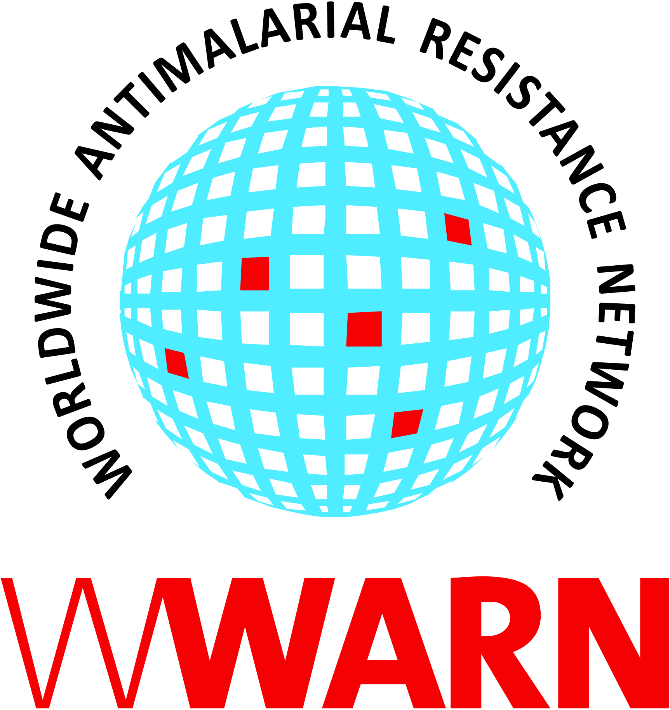

Suggested citation: WWARN Procedure. Collection of blood by finger prick or heel stick v2.0

Procedure ID: CL11
This procedure was developed by: WWARN

Version History
Version number | Revision(s) & reason for amendment | Release Date
1.0 | Creation of procedure | 28Jul2010
1.1 | Formatting | 18Aug2010
1.2 | Changes to template | 27Oct2010
2.0 | Updated nomenclature, other minor administrative changes | 14Sep2018

For more information, contact:
info@wwarn.org

WorldWide Antimalarial Resistance Network (WWARN) www.wwarn.org

Contents

1. Purpose/scope 4
2. Abbreviations 4
3. Definitions 4
4. Associated forms 4
5. Duties and responsibilities 4
5.1 Tasks 4
5.2 Materials and equipment 4
6. Procedures 4
6.1 General guidelines 4
6.2 Taking sample 5
7. References 5

1. Purpose/scope
This document describes the procedure for obtaining fingerprick and heel stick blood samples for preparing thick/thin blood smears and filter paper samples; to ensure patient and staff safety during procedure, proper specimen identification and labelling, and proper disposal of sharps and other biohazardous waste. This procedure is intended for use in clinical trials where patients are attending a clinic for antimalarial treatment. Blood specimens are obtained for laboratory evaluation of the patient. The specimen should be collected in the manner described below to minimize the patient’s discomfort and to ensure collection of the required amount of blood.

2. Abbreviations

None

3. Definitions
None

4. Associated forms
None

5. Duties and responsibilities

5.1 Tasks
Tasks can be assigned to individual(s) capable of their execution and their name entered beside the task listed in the table below and/or as recorded on a delegation of responsibilities/tasks documentation:

Study personnel
Explain the procedure to the patient
Take blood from patient via finger prick or heel stick

5.2 Materials and equipment
- Alcohol swabs or isopropyl alcohol or chlorhexidine solution for skin disinfection
- 10% household bleach (JIK) or 4% chlorhexidine solution and absorbent material for cleaning up spills and splashes
- Gloves
- Dry gauze pads or cotton balls
- Blood lancet Giemsa buffer [Na2HPO4 (dibasic anhydrous), Na2HPO4*H2O (monobasic monohydrate), distilled water)
- Frosted slides
- Filter paper
- Puncture-resistant labelled sharps disposable container

6. Procedures

6.1 General guidelines
Wear latex gloves and use aseptic technique during finger prick and/or heel stick. Gloves should be changed between patients. Gloves should be worn when handling or transporting specimens if there is any possibility of direct contact with blood or other body secretion. Any blood spills or splashes should be immediately cleaned up with absorbent material using an approved disinfectant such as dilute 10% bleach or chlorhexidine solution. No food or drink should be permitted in the clinic work area. Discarded swabs, needles, and other items should be placed in designated puncture-resistant labeled biohazardous waste containers.

6.2 Taking sample
- Explain the finger prick or heel stick procedure to the patient and/or parent/guardian.
- Disinfect the finger prick or heel stick site by swabbing the skin in small outward circles with an alcohol swab or cotton swab soaked with alcohol or chlorhexidine solution.
- Once the alcohol dries prick the area with a disposable lancet. If done properly a single prick should be sufficient to collect all of the blood required.
- Apply moderate pressure, approximately 1 cm behind the site of the puncture, to obtain a drop of blood. Do not squeeze too tightly as it will cause tissue plasma to mix with and dilute the blood.
- Release this pressure immediately to allow recirculation of the blood.
- Repeat the last 2 steps until enough blood has been collected.
- Apply a piece of gauze or cotton wool to the puncture site using slight pressure until the bleeding has stopped.

7. References
None

