Collection of samples for artemisinin pharmacology analysis

Procedure

WorldWide Antimalarial Resistance Network (WWARN)
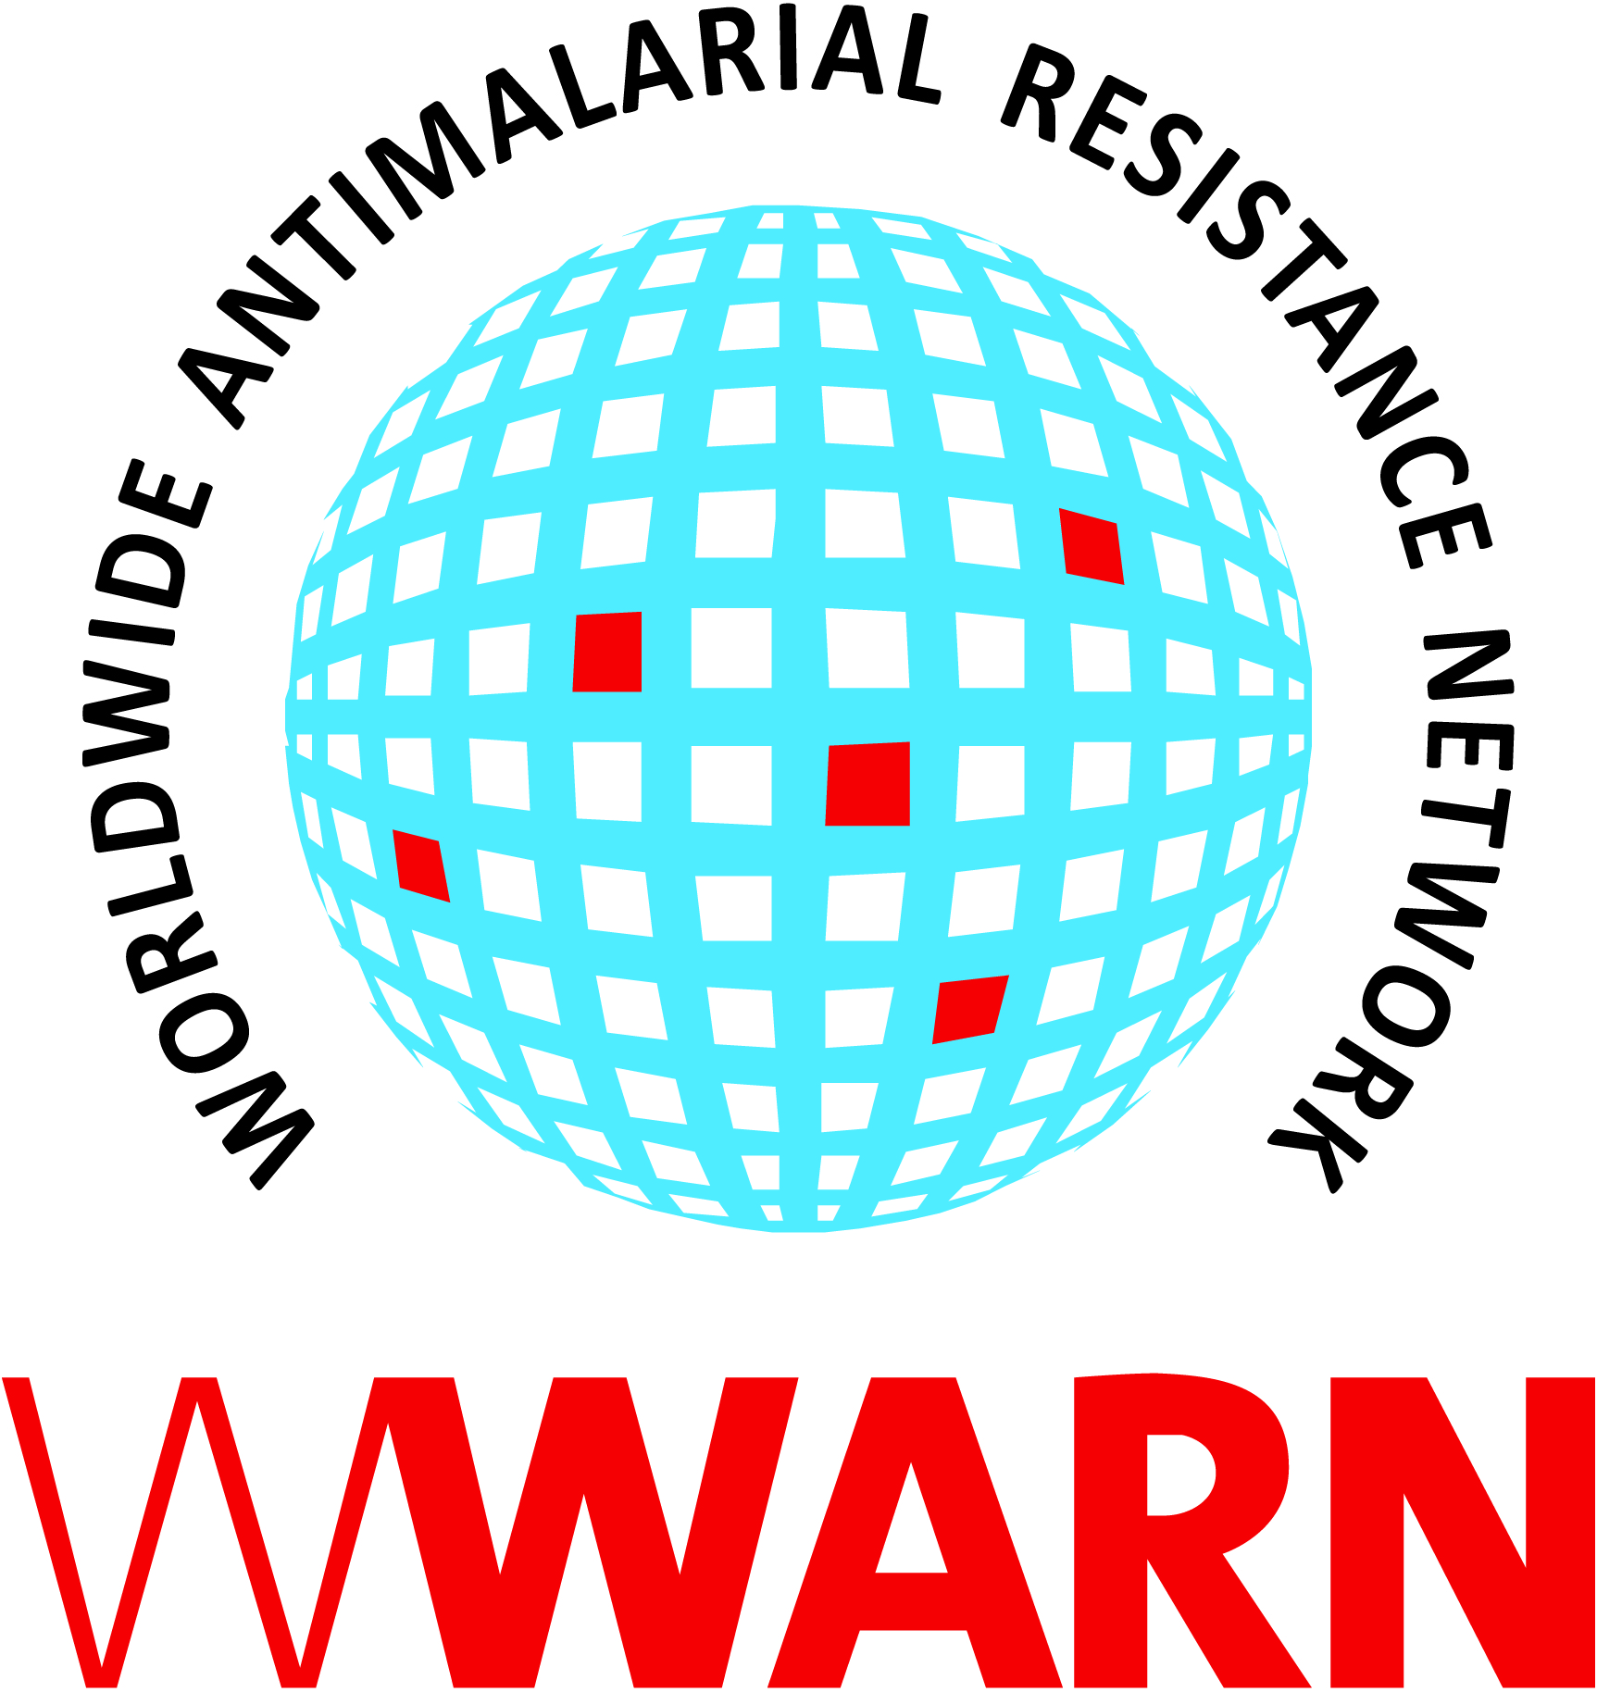

Suggested citation: WWARN Procedure. Collection of samples for artemisinin pharmacology analysis v2.0

Procedure ID: CL22
This procedure was developed by: WWARN

Version History
Version number | Revision(s) & reason for amendment | Release Date
1.0 | Creation of procedure | 02Oct2015 (Chris Lourens, Joel Tarning)
2.0 | Updated nomenclature, other minor administrative changes | 14Sep2018

For more information, contact:
info@wwarn.org

WorldWide Antimalarial Resistance Network (WWARN) www.wwarn.org

Contents

1. Purpose 4
2. Scope 4
3. Abbreviations 4
4. Duties and responsibilities 4
5. Materials 4
Anticoagulants 5
6. Procedure 5
7. Sampling times 5
8. Stability 6
9. References 6

1. Purpose
The purpose of this document is to standardize the sample collection procedure during clinical studies of artemisinin antimalarial drugs. This should be considered as a recommendation or as a definition of minimum requirements, created by the Worldwide Antimalarial Resistance Network (WWARN), aiming to achieve homogeneous quality in the pre-analytical phase of studies and to provide guidelines in the processes of collection, processing, preserving, storage, shipment and safe handling of samples from human origin.

2. Scope
This document applies to those sites wishing to conduct clinical trials to assess the pharmacokinetics/pharmacodynamics of artemisinin to support antimalarial drug investigation.

NOTE: It is crucial to contact the analytical laboratory before commencement of the study to inquire about specific requirements of that particular laboratory.

3. Abbreviations
WWARN Worldwide Antimalarial Resistance Network
QA/QC Quality assurance / quality control
ARM Artemether
ART Artesunate
DHA Dihydroartemisinin

4. Duties and responsibilities
The tasks to be completed for this procedure are listed below. Each of these must be assigned to an individual(s) who has been trained to perform these tasks and in the use of relevant health and safety precautions.
- Proper identification of patient and matching samples
- Collection of samples
- Processing of samples

5. Materials
Samples for pharmacology analysis of artemisinin must be collected in plastic containers and transferred to screw cap polypropylene cryovials for transportation and storage. The tubes should be pre-chilled on wet ice prior to use. After collection of blood, the tube should be placed on wet ice and processed as soon as possible. Use of plastic sampling and storage containers minimizes the risk for analyte adsorption and improves safety at the site.

Anticoagulants
Artesunate / dihydroartemisinin: Sodium fluoride/potassium oxalate must be used as an anticoagulant. ⁽¹⁾
Artemether / dihydroartemisinin: Sodium or lithium heparin must be used as an anticoagulant. ⁽²⁾
Dihydroartemisinin: Either sodium fluoride / potassium oxalate or heparin (sodium or lithium must be used as an anticoagulant. ^{(1, 2)}

0.4 M potassium dichromate should be used for whole blood sample collection to stabilize artemisinin.

6. Procedure
Analysis of artemisinin may be done in whole blood or plasma per the validated bioanalytical method used for the analyses. As of today no validated methods for whole blood applied on filter paper are available.

- Collect the required volume of whole blood following the local protocol for the collection of blood.
Note: A catheter may be needed for dense sampling to reduce venipunctures. The minimum volume required may differ for individual laboratory methods. Please contact the laboratory first to obtain more information on specific needs. Mass spectrometry-based methods commonly require smaller volumes in the range of 100-500 microliters, and UV-based methods commonly require volumes in the range of 500-1000 microliters.

- Whole blood: Transfer whole blood directly into pre-chilled, pre-labelled (Patient ID, date and clock time of collection) polypropylene cryovials with added anticoagulant and potassium dichromate (0.4 M) to stabilize the blood samples. Store frozen at -80ºC (see section 8 below), do not thaw the sample after freezing.
- Plasma: The tubes should be pre-chilled on wet ice prior to use. After collection of blood, the tube should be placed on wet ice and processed as soon as possible after collection (the samples can be placed in the ice bath for 5 to 10 minutes prior to centrifugation to allow the blood to chill in the tube). Centrifuge anticoagulated whole blood within 15 minutes of sampling at 4ºC, 2000 x g for 7 minutes. Transfer the plasma into pre-labelled (Patient ID, date and clock time of collection) polypropylene cryovials. Store frozen (see section 8 below), do not thaw the sample after freezing.

7. Sampling times
Sampling times should be verified by a pharmacologist to ensure an informative clinical trial design. The sampling times vary depending on intended analysis technique (i.e. model-independent or model-based analysis) and also with the specific aim of the study ⁽¹⁾.

Suggested dense sampling times ⁽²⁾:

Single dose Hour: 0, 0.25, 0.5, 0.75, 1, 1.25, 1.5, 3, 4, 6, 8

8. Stability
Venous blood and plasma samples for artemisinin must be frozen at -80ºC immediately after collection and processing. Venous blood samples must be collected into chilled tubes on wet ice. Storage at -80ºC is crucial. Do not thaw samples after freezing.

Degradation of these drugs are highly dependent upon temperature. Keeping a low temperature (i.e. pre-chilled tubes and ice) as soon as possible after collection and until the sample has been put into the freezer significantly reduces degradation.

9. References
- These tubes are available from commercial sources but can also be prepared as follows. Make a stock solution containing 20 mg/ml sodium fluoride and 30 mg/ml potassium oxalate. Add 100 µL (based on collection of 1 ml blood) of this solution to each tube. Dry down by speed vac or suitable evaporation device. Store dried tubes at ambient temperature.
- Methods and techniques for assessing exposure to antimalarial drugs in clinical field studies. WHO. ISBN 978 92 4 150206 1, p43.

