Guidelines for the collection of samples for piperaquine pharmacology analysis

Pharmacology Module
WorldWide Antimalarial Resistance Network (WWARN)
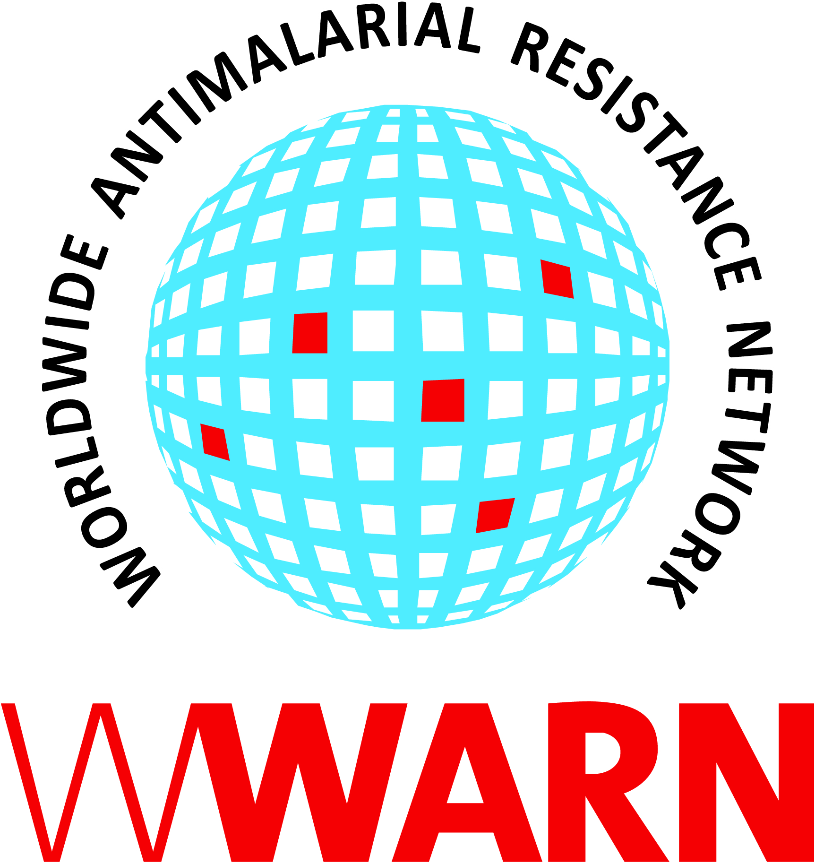

© 2011 WorldWide Antimalarial Resistance Network (WWARN)
This publication may be quoted or reproduced without charge, provided the source is acknowledged. No use of this publication may be made for resale or other commercial purposes. All images remain the sole property of their source and may not be used without written permission of the source.

Suggested citation: Pharmacology Module, WWARN. 2015. Guidelines for the collection of samples for piperaquine pharmacology analysis v1.0. WWARN Procedure.

Procedure ID: PHA08
This procedure was developed by:

Pharmacology Module

Version History
Version number | Revision(s) & reason for amendment | Date of approval | Issued by | Approved by
1.0 | New document | 02/10/2015 | Chris Lourens | Joel Tarning

Contents

1. Purpose 4
2. Scope 4
3. Abbreviations 4
4. Duties and Responsibilities 4
5. Materials 4
6. Procedure 5
7. Sampling times 5
8. Stability 6
9. Reference 6

1. Purpose
The purpose of this document is to standardize the sample collection procedure during clinical studies of piperaquine antimalarial drugs. This should be considered as a recommendation or as a definition of minimum requirements, created by the Worldwide Antimalarial Resistance Network (WWARN), aiming to achieve homogeneous quality in the pre-analytical phase of studies and to provide guidelines in the processes of collection, processing, preserving, storage, shipment and safe handling of samples from human origin.

2. Scope
This document applies to those sites wishing to conduct clinical trials to assess the pharmacokinetics/pharmacodynamics of piperaquine to support antimalarial drug investigation.

NOTE: It is crucial to contact the analytical laboratory before commencement of the study to inquire about specific requirements of that particular laboratory.

3. Abbreviations
WWARN Worldwide Antimalarial Resistance Network
QA/QC Quality assurance / quality control
PQ Piperaquine

4. Duties and Responsibilities
The tasks to be completed for this procedure are listed below. Each of these must be assigned to an individual(s) who has been trained to perform these tasks and in the use of relevant health and safety precautions.
- Proper identification of patient and matching samples
- Collection of samples
- Processing of samples

5. Materials
Samples for pharmacology analysis of PQ must be collected in plastic containers and transferred to screw cap polypropylene cryovials for transportation and storage. The tube should be at room temperature (18°- 25° C) prior to use. Use of plastic sampling and storage containers minimizes the risk for analyte adsorption and improves safety at the site.

Choice of the paper used to collect dried blood spot samples must be made in consultation with the analytical laboratory.

EDTA or sodium or lithium heparin must be used as an anticoagulant. ⁽¹⁾

6. Procedure
Analysis of PQ may be done in whole blood, plasma or dried blood spots per the validated bioanalytical method used for the analyses. Plasma and whole blood matrices are the most commonly used sampling procedures.

- Collect the required volume of whole blood following the local protocol for the collection of blood.
Note: A catheter may be needed for dense sampling to reduce venipunctures. The minimum volume required may differ for individual laboratory methods. Please contact the laboratory first to obtain more information on specific needs. Mass spectrometry-based methods commonly require smaller volumes in the range of 100-500 microliters, and UV-based methods commonly require volumes in the range of 500-1000 microliters.

- Whole blood: Transfer whole blood directly into pre-labelled (Patient ID, date and clock time of collection) polypropylene cryovials with added EDTA or sodium or lithium heparin as anticoagulant. Store frozen (see section 8 below), do not thaw the sample after freezing.
- Plasma: Centrifuge EDTA or sodium or lithium heparin anticoagulated whole blood within 60 minutes of sampling at 1000 – 3000 x g for 7 – 15 minutes. Transfer the plasma into pre-labelled (Patient ID, date and clock time of collection) polypropylene cryovials. Store frozen (see section 8 below), do not thaw the sample after freezing.
- Dried blood spots: Apply whole blood directly to pre-labelled (Patient ID, date and clock time of collection) filter paper. If dried spot methodology is used, contact the laboratory to obtain more information on paper specifications, drying and storage conditions.

7. Sampling times
Sampling times should be verified by a pharmacologist to ensure an informative clinical trial design. The sampling times vary depending on intended analysis technique (i.e. model-independent or model-based analysis) and also with the specific aim of the study ⁽¹⁾.

Suggested dense sampling times ⁽¹⁾:

Three doses (0, 24, 48 h) Hour: 0, 1, 2, 4, 6, 8, 26, 50, 56
Days: 3, 4, 7, 14, 35, 63

8. Stability
PQ is stable in plasma at 4ºC for up to 48 hours. Venous blood samples should not be stored for more than 1 hour at room temperature. It can also be stored at -20ºC for up to three months. Long term storage at -80ºC is usually sufficient for at least 1 year.

9. Reference

- Methods and techniques for assessing exposure to antimalarial drugs in clinical field studies. WHO. ISBN 978 92 4 150206 1, p43.

