Post-exposure prophylaxis in the clinical trial facility v2.0

Procedure

WorldWide Antimalarial Resistance Network (WWARN)

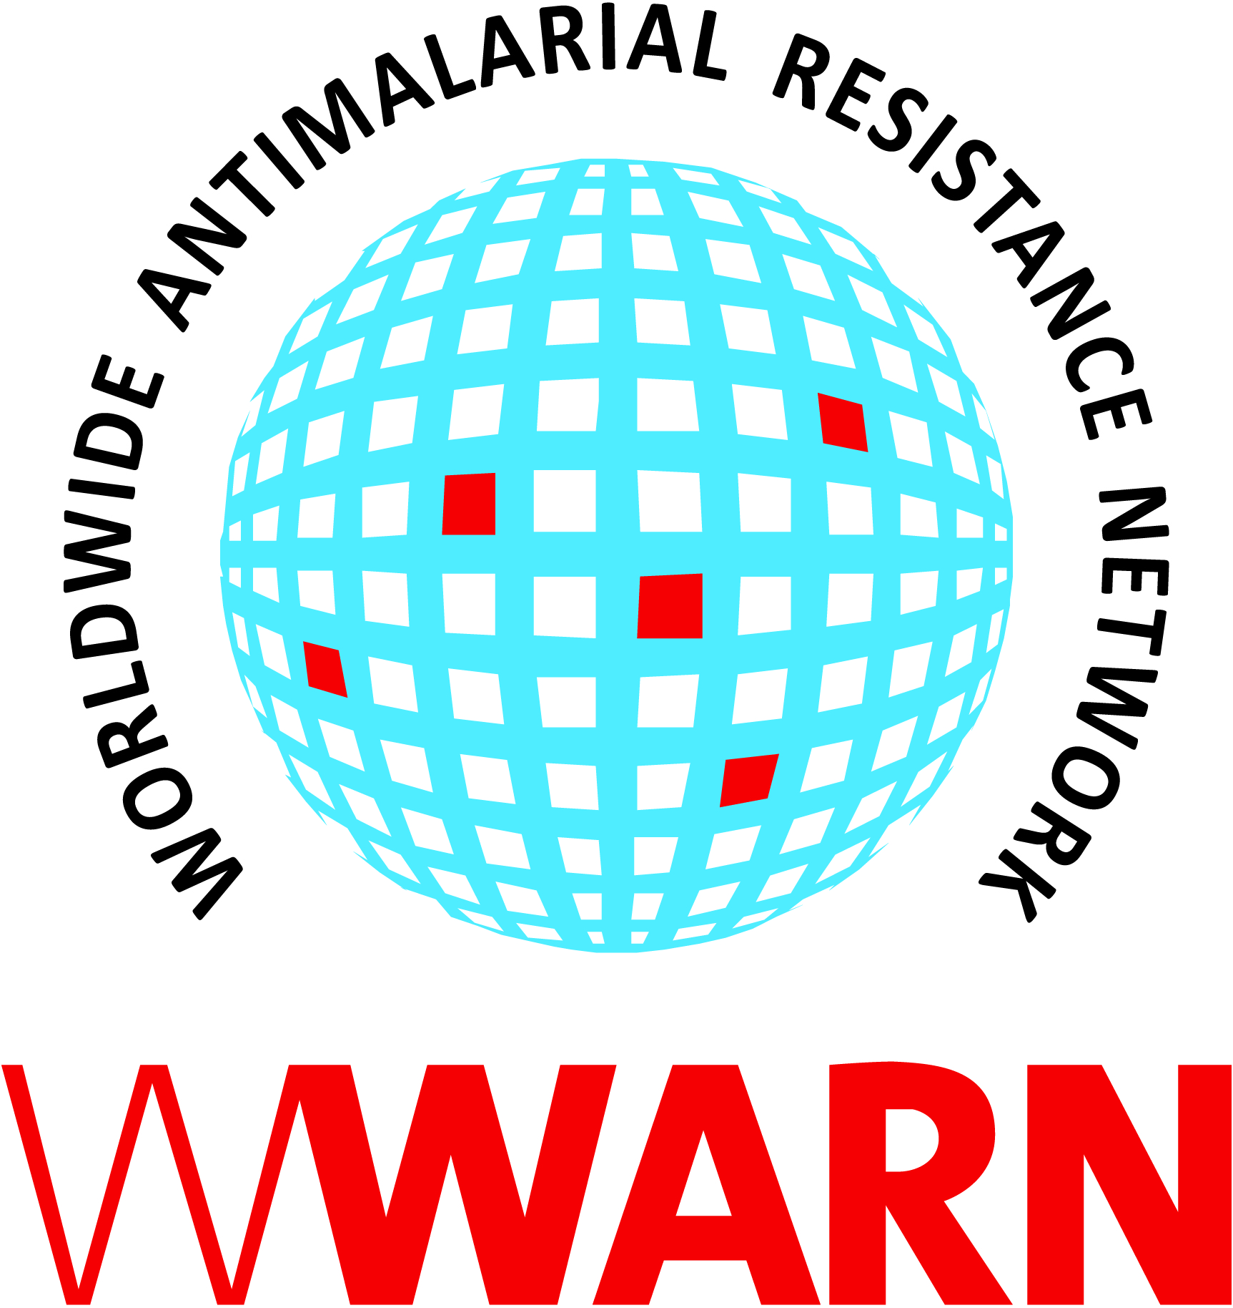

Suggested citation: WWARN Procedure. Post-exposure prophylaxis in the clinical trial facility v2.0

Procedure ID: SAF03
This procedure was developed by:

The Collaborating Centre for Optimising Antimalarial Therapy (CCOAT), Division of Clinical Pharmacology, Department of Medicine, University of Cape Town, Cape Town, South Africa

Version History
Version number | Revision(s) & reason for amendment | Release Date
1.0 | Creation of procedure | 14Apr2018
2.0 | Updated nomenclature, other minor administrative changes | 14Sep2018

For more information, contact:
info@wwarn.org

WorldWide Antimalarial Resistance Network (WWARN) www.wwarn.org

Contents

1. Purpose/scope 4
2. Abbreviations 4
3. Definitions 4
4. Associated forms 4
5. Procedure 4
5.1 What is exposure to potentially infectious fluids? 4
5.2 First priority – exposed person 4
5.3 Second priority – source person 5
6. References 5

1. Purpose/scope
Trial staff and participants may be inadvertently exposure to potentially infectious fluids during a clinical trial. This procedure therefore describes the process for dealing with such exposure and applies to all team members working on a trial.

2. Abbreviations
None

3. Definitions
Accidental exposure
Needle-stick injuries; injury with other sharp object, e.g. scalpel blade, lancet, suture needle, broken glass; splash of blood or body fluids onto mucous membrane of eyes, mouth or nose; exposure of non-intact skin to blood or body fluids.

Potentially infectious fluids
Blood, CSF, semen, vaginal secretions, synovial / pleural / pericardial / peritoneal / amniotic fluids, but not vomitus, faeces, urine, saliva, sweat, tears unless blood stained.

4. Associated forms
None

5. Procedure

5.1 What is exposure to potentially infectious fluids?
- Needle stick or sharp object contamination with potentially infectious fluid
- Splash of infectious fluid into eyes or mouth
- Exposure of non-intact skin to blood/blood stained fluids

5.2 First priority – exposed person
Immediate action at the scene of incident is to:
- Wash the injured/exposed area thoroughly
- Notify the Principal (PI), Lead or another on-call investigator (depending on who is available)
- IMPORTANT: Arrange prophylactic treatment for the exposed person as soon as possible (within 4 hours of exposure). NOTE: the exposed person will only receive HIV post-exposure prophylaxis after confirming they are not already known to be HIV positive or pregnant and have been informed about potential adverse effects of the post-exposure prophylaxis
- During work hours (07:00-16:00) refer him/her to the Occupational Health Clinic (__________________) who will conduct all necessary counselling, blood tests, treatment and follow-up. The trial team member in charge at the time of the incident must promptly inform the clinic by phone so that they will expect the exposed person
- After hours (16:00-07:00) the on-call investigator may start post-exposure prophylaxis treatment in the trial facility or refer the exposed person to the nearest trauma unit (_________________). A designated member of the trial team should then facilitate that the exposed person proceeds to the Occupational Health Clinic on the next working day
- If the baseline HIV test of the exposed person indicates the presence of HIV infection, prophylactic management is no longer appropriate, and he/she may be referred to an appropriate clinic of their choice for further advice and management
- The potential risk and responsibility for prophylactic treatment can only be justified if baseline blood testing indicates a HIV negative status of the exposed person prior to the incident. If the exposed person refuses baseline testing, no prophylactic treatment will be given, and prophylactic treatment started after hours will be stopped

5.3 Second priority – source person
- The source person must be informed of the incident and asked for consent for the following tests to be taken and being made available to the exposed person and the Occupational Health clinician: HIV, hepatitis B/C and syphilis. Testing the source person can wait for the next day, but post-exposure prophylaxis of the exposed person should NOT be delayed while waiting for the results
- The trial team member facilitating testing of the source person must arrange for a 6ml clotted blood sample to be taken, after full pre-test counselling and informed consent. Trial staff with training may conduct the counselling or an alternative counsellor should be arranged
- The blood specimen should be labelled with the following:
  - Source person’s identity details
  - His/her trial number (if applicable), date and trial name/number.
  - Occupational Health Clinic telephone number (see above).
- The request form of the source person must indicate the following:
  - That it is an URGENT NEEDLE STICK/EXPOSURE case
  - Which blood tests are required – HIV, hepatitis B/C and syphilis
  - The trial name/number
- Transport of the specimen to the hospital virology laboratory is arranged and the lab informed it is en route (_________________)
- The Occupational Health clinician is informed about the incident by phone during office hours

5.4 Documentation
- The trial team member facilitating testing of the source person (if a trial participant) should ensure that all relevant trial source documents are completed
- All medical records should remain confidential as per usual medical practice, particularly as regards the health status of the exposed person.

6. References
None

