Medical emergencies at field trial sites v2.0

Procedure

WorldWide Antimalarial Resistance Network (WWARN)
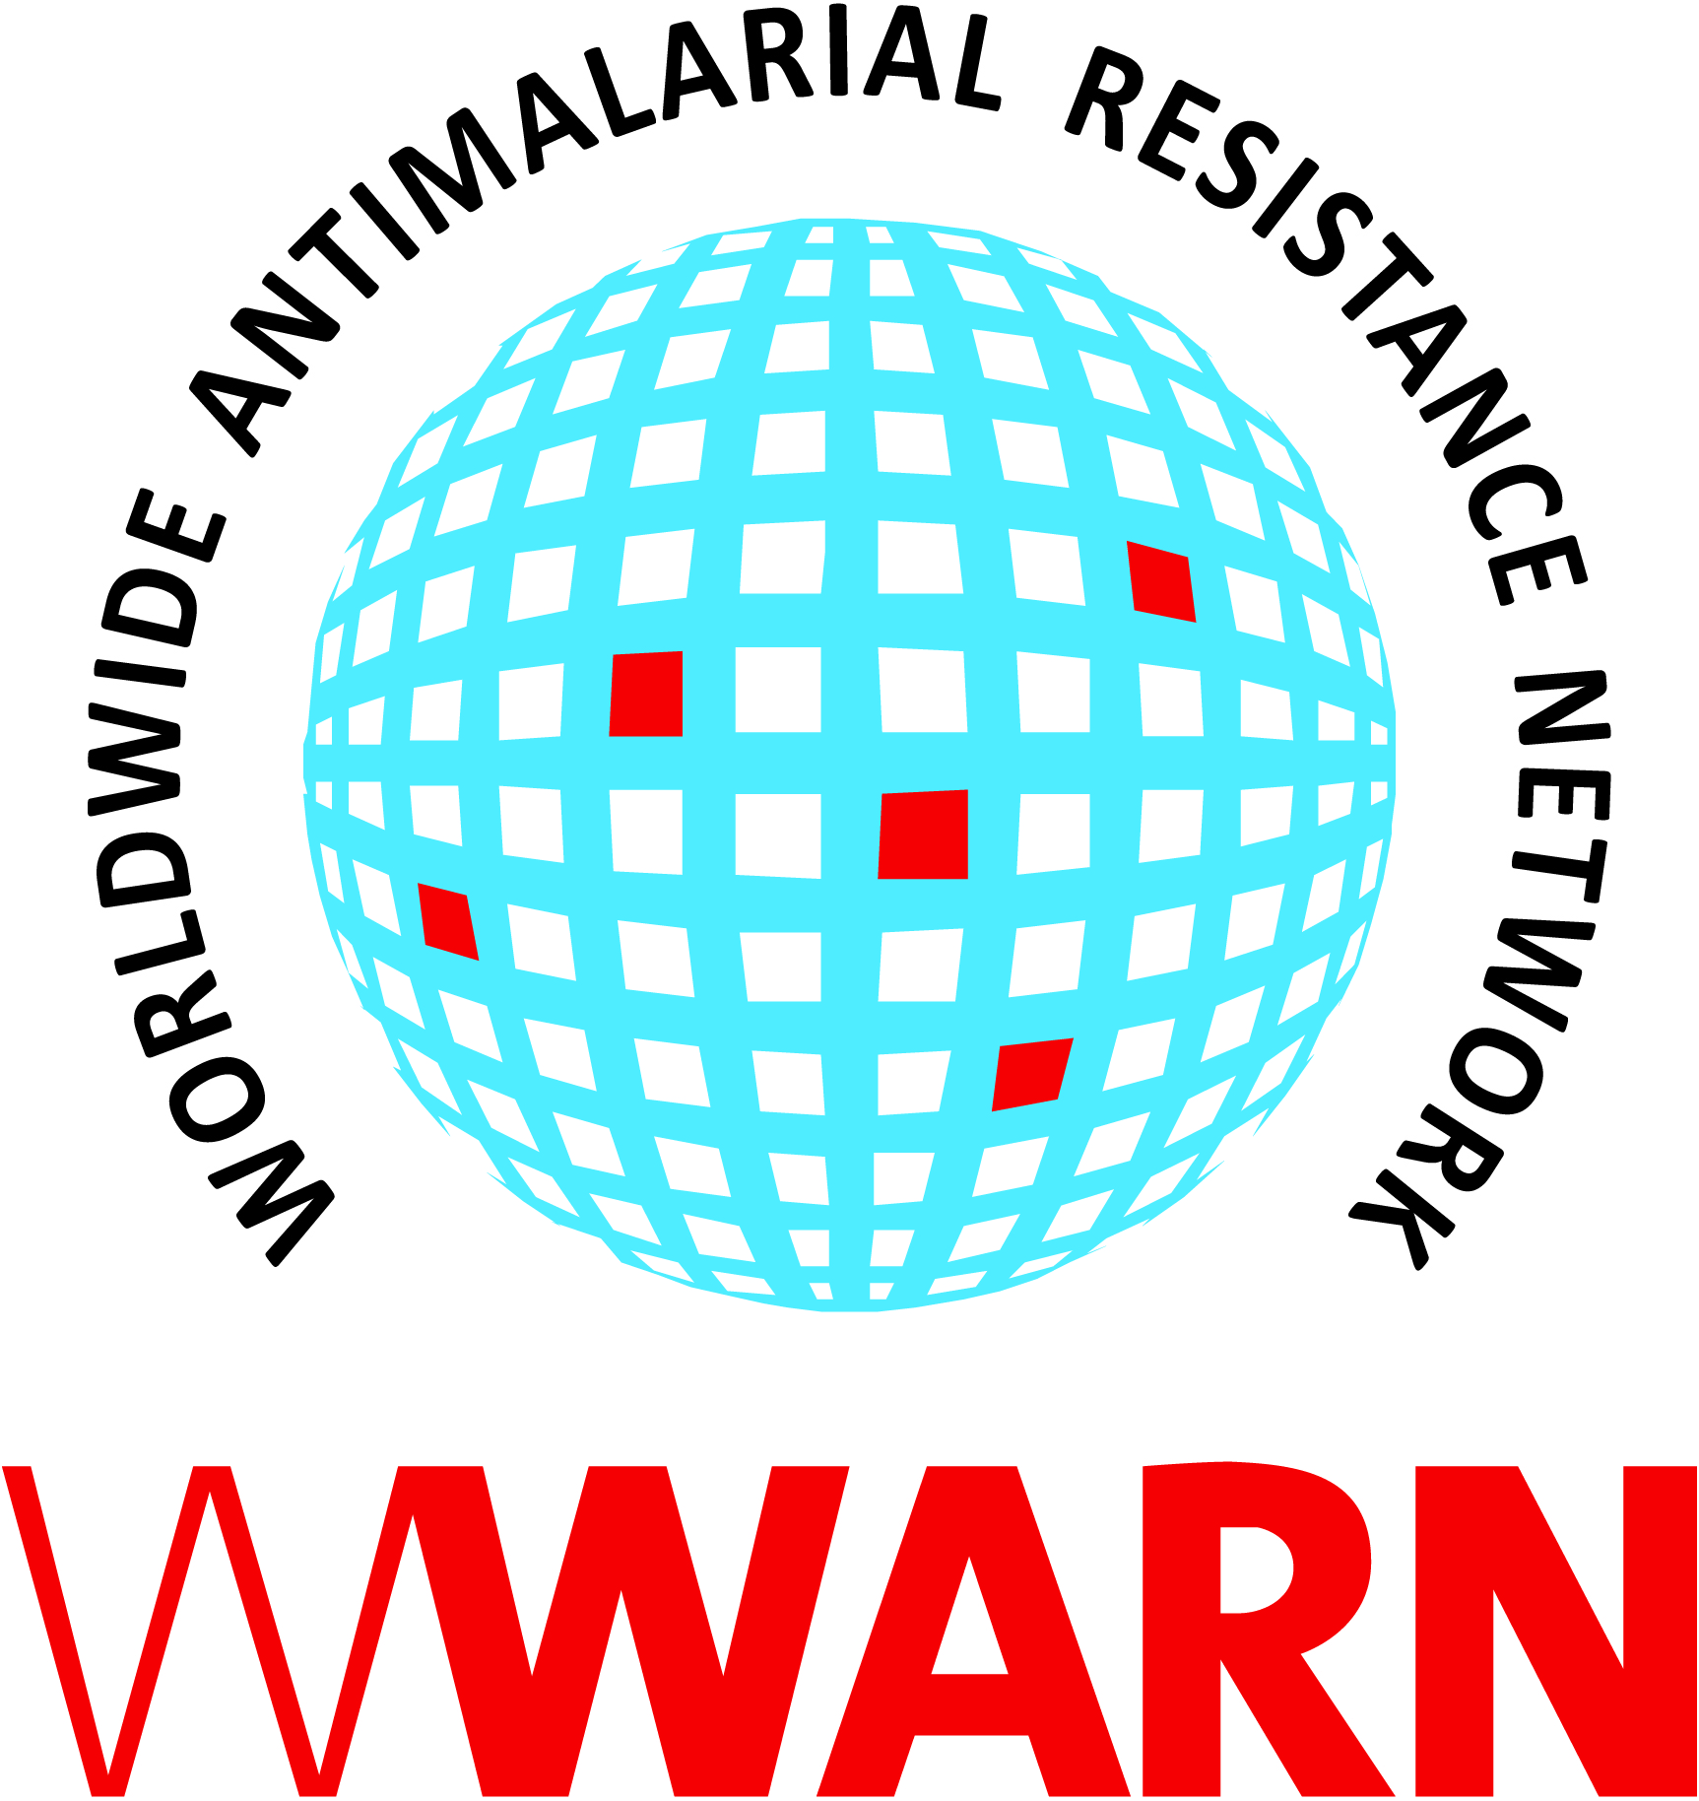

Suggested citation: WWARN Procedure. Medical emergencies at field trial sites v2.0

Procedure ID: SAF05
This procedure was developed by:

The Collaborating Centre for Optimising Antimalarial Therapy (CCOAT), Division of Clinical Pharmacology, Department of Medicine, University of Cape Town, Cape Town, South Africa

Version History
Version number | Revision(s) & reason for amendment | Release Date
1.0 | Creation of procedure
2.0 | Updated nomenclature, other minor administrative changes | 14Sep2018

For more information, contact:
info@wwarn.org

WorldWide Antimalarial Resistance Network (WWARN) www.wwarn.org

Contents

1. Purpose 4
2. Abbreviations 4
3. Definitions 4
4. Associated forms 4
5. Procedure 4
5.1 Responsibilities and planning 4
5.2 Process in the event of a medical emergency 4
5.3 Documentation 5
6. References 5

1. Purpose
The rights, safety and well-being of trial participants are the most important considerations in a clinical trial, and the investigator/intuition should ensure that adequate medical care is provided for any adverse events (AEs) (ICH GCP(R2)). WWARN Procedure SAF02 described a process for safely evacuating a participant due to a medical emergency from a clinical trial facility and is particularly important for sites conducting early-phase trials when planning is critical. This procedure describes the process for managing medical emergencies in trial participants at field sites and applies to all staff working within a typical clinic set-up. The exact nature of evacuation and the roles of staff will, however, depend on the trial and site set-up.

2. Abbreviations
AE Adverse Event
GCP Good Clinical Practice
ISF Investigator Site File
PI Principal Investigator
SAE Serious Adverse Event

3. Definitions
Adverse event (AE)
Any untoward or unfavourable medical or psychological occurrence in a participant, including any abnormal laboratory finding, symptom or disease. An AE does not necessarily have a causal relationship with the research or any risk associated with the research.

Serious Adverse Event (SAE) or Serious Adverse Drug Reaction
Any untoward medical occurrence that at any dose, results in death, is life-threatening, requires inpatient hospitalization or prolongation of existing hospitalization, results in persistent or significant disability/incapacity, or is a congenital anomaly/birth defect.

4. Associated forms
None

5. Procedure

5.1 Responsibilities and planning
All clinically qualified trial team members at the site must be able to deal with emergency medical situations according to their qualification, and they should be able to access the resuscitation/emergency trolley (maintained as per local requirements).

5.2 Process in the event of a medical emergency
- The participant should be rapidly assessed and stabilised by the clinical staff on duty, with the most senior person(s) taking the lead
- If the participant’s condition is deemed unstable, an ambulance should be called according to the normal practice for that clinic/hospital. Resuscitation should be continued, if needed, until hand over to the ambulance service
- If the participant’s condition is deemed stable, an investigator should be consulted, to decide on further management and referral to clinical care

5.3 Documentation
All relevant trial documents should be completed, including the AE/SAE forms, and the appropriate authorities (Sponsor, regulatory authority, ethics committee) notified of the event according to trial-specific safety procedures.

6. References
ICH E6 (R2) Good Clinical Practice, 2016. Available from: http://www.ich.org/fileadmin/Public_Web_Site/ICH_Products/Guidelines/Efficacy/E6/E6_R2__Step_4_2016_1109.pdf (Accessed 27 March 2018)

