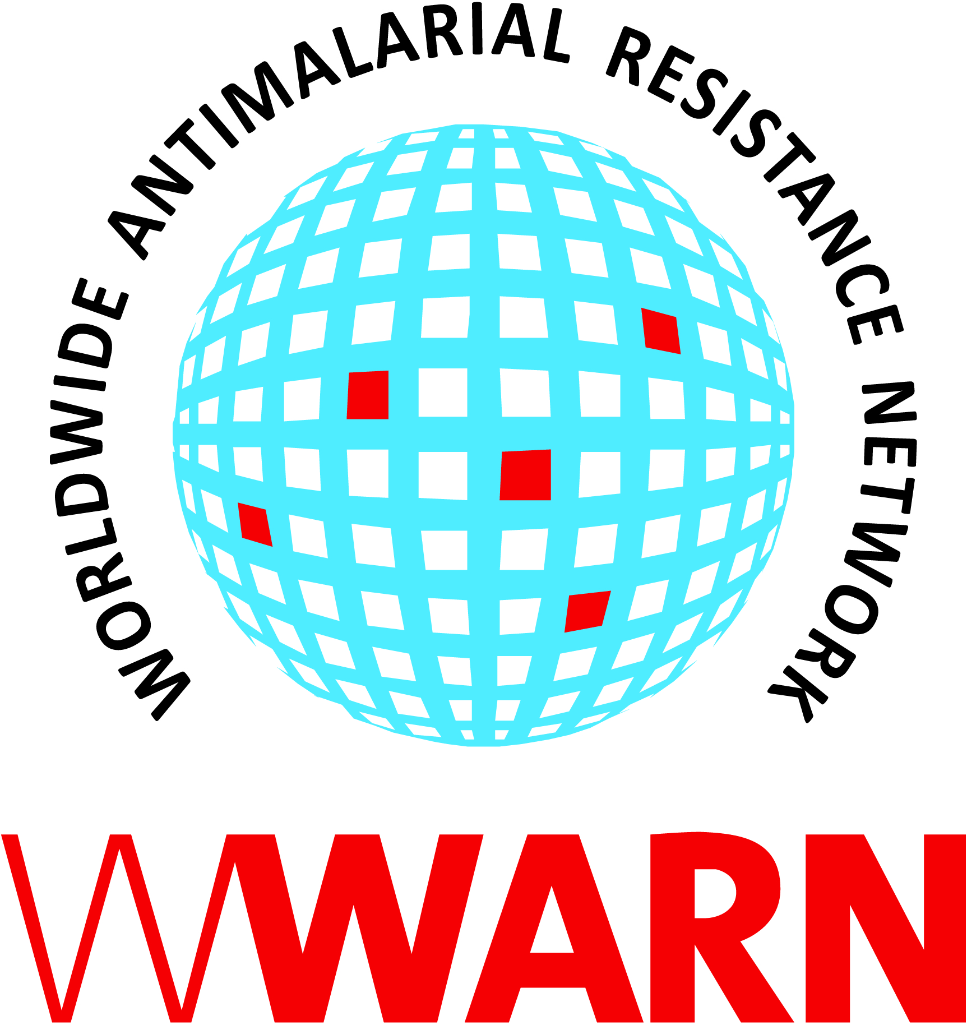 **ASTMH 2013 – A Summary of WWARN Activities & WWARN Supported Sessions**

|  |  |
| --- | --- |
| **THURSDAY, NOVEMBER 14** |  |
| **Symposium – Ric Price**  **Ballroom Salon 3 / Session 4**  **08:00-09.45** | Presentation: Drug combinations for treatment and transmission blocking of malaria  Session: Rational strategies for development of new combinations for treatment of malaria  Other panellists: Babu L. Tekwani (organizer), Larry Walker (co-chair), Joel Tarning and J. Kevin Baird |
| **Poster - Clarissa Moreira**  **Session A Noon – 1:45pm** | Addressing data heterogeneity and long-term storage: the WWARN experience |
| **FRIDAY, NOVEMBER 15** |  |
| **Scientific Session**  **Ballroom Salon 3 / Session 62**  **08:00-09.45** | Presentation: The effect of drug quality on the spread of antimalarial resistance in *Plasmodium falciparum*  Session: Malaria: using genetic tools to understand antimalarial resistance  Other presenters: Daouda Ndiaye (co-chair), Steve M. Taylor (co-chair), Melissa D. Conrad, Christopher G. Jacob, Aleisha R. Brock, Carola J. Salas, Lindsay C. Morton and Stanley C. Xie *(Aleisha Brock session supported by Ric Price)* |
| **Poster – Jennifer Flegg**  **Session B**  **Noon – 13:45** | Sampling design for the Parasite Clearance Estimator: two complementary methodological approaches |
| **Poster – Clarissa Moreira**  **Session B Noon – 13:45** | Clinical determinants for early parasitological response in patients diagnosed with uncomplicated malaria in *Africa* treated with artemisinin combination therapies: a pooled analysis of individual patient data |
| **Poster – Jennifer Flegg**  **Session B Noon – 13:45** | Mapping artemisinin resistance: smart surveillance |
| **Poster - Ric Price**  **Session B**  **Noon – 13:45** | Assessing the effect of the recommended artemether-lumefantrine dosing regimen on the risk of treatment failure in patients diagnosed with uncomplicated *P. falciparum* malaria |
| **Poster - Aimee Taylor**  **Session B Noon – 13:45** | The impact of malaria control interventions on antimalarial drug resistance:  measuring the role of changes in multiplicities of infection |
| **Poster – Carol Sibley**  **Session B Noon – 13:45** | WWARN *In Vitro* Pilot Project: how to reduce variability for *in vitro* susceptibility testing of antimalarial drugs |
| **SATURDAY, NOVEMBER 16** |  |
| **Oral Pres.–Christian Nsanzabana**  **Ballroom Salon 3 / Session 117**  **08:00 – 10:00** | Presentation: Treatment efficacy of artesunate-amodiaquine treatment regimens for uncomplicated *P. falciparum* malaria: a comparison of fixed versus co-blister formulations  Session: Malaria: Chemotherapy II  Other panellists: Yesim Tozan, Bernhards Ogutu, Ifeyinwa N. Chijioke-Nwauche, Jason W. Bennett, Myaing M. Nyunt, Sean E. Clarke and Nicholas White |
| **Symposium – Patricia Tabernero**  **Ballroom Salon 3 / Session 143**  **13:45 – 15:30** | Presentation: Understanding the prevalence and distribution of poor quality antimalarials  Session: Innovative field tools for detecting counterfeit medicines  Other panellists: Joel Bremen, James Herrington, Facundo M. Fernandez, Muhammad H. Zaman and Leigh Verbois |
| **Poster – Prabin Dahal**  **Session C Noon – 13:45** | Early parasitological response in patients treated with artemisinin combination therapies in *Asia*: a pooled analysis of individual patient data |