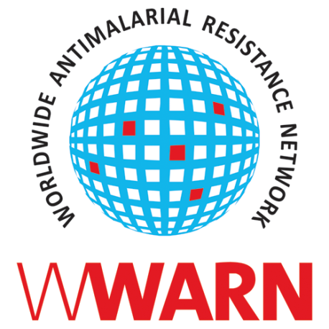
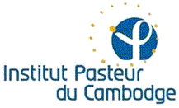

Artemisinin Resistance
Monitoring Tools Workshop

WWARN In Vitro Module

Didier Ménard, Benoit Witkowski,
Anaïs Domergue

Institut Pasteur in Cambodia
Phnom Penh, Cambodia
29 September – 3 October 2014
Overview

The Ring-stage Survival Assay (RSA) allows the laboratory assay of parasite sensitivity to delay development after artemisinin treatment. The assay has been shown to correlate with the slow clearance phenotype observed in Cambodia [1],[2] . A detailed RSA procedure has been developed by Benoit Witkowski and Didier Ménard at the Institut Pasteur in Cambodia and further improved in collaboration with Chanaki Amaratunga and Rick M. Fairhurst, Laboratory of Malaria and Vector Research, NIAID, NIH (URL). In order to enlarge the community of malaria researchers who can utilise this new assay, the WWARN network will sponsor a 5 day practical RSA workshop in Phnom Penh, Cambodia from 29 September to 3 October.
The workshop is intended to train researchers from malaria endemic regions who have proven expertise in malaria culture and the standard in vitro assay of drug susceptibility (see below for detailed requirements). All costs of the workshop activities will be supported by WWARN, however, participants must pay for the costs of their own round trip travel to Phnom Penh and their accommodation and maintenance costs during the workshop. It is estimated that visa, accommodation and maintenance will cost each participant 700 USD, plus your travel costs.
- Informal inquiries are encouraged and should be directed to WWARN’s Head of In Vitro Module, Didier Menard ,and In Vitro Coordinator Benoit Witkowski

- Senior sponsors, departmental officials or Laboratory Heads supporting applicants to submit an application should send the following information to Didier Menard and Benoit Witkowski before 15 August.
  - Evidence that the laboratory has the equipment needed and demonstrated success in drug susceptibility assays and basic in vitro culture of field isolates of P. falciparum
  - Details of proven experience that the applicant himself / herself is experienced with these assays
  - A plan of how the laboratory intends to employ the RSA in its own research activities.
  - Confirmed support that the applicant will have the resources to attend, if selected.

For further information, please contact Didier Menard (dmenard@pasteur-kh.org) and Benoit Witkowski via email (bwitkowski@pasteur-kh.org)
The outline of the full workshop agenda is on page 3.

Summary of the agenda

 | Monday | Tuesday | Wednesday | Thursday | Friday
Morning | (9-11 am)  Introduction & presentation  Objectives of the training & Presentation of the Ring-stage Survival Assays | (8-11 am)  Workshop  step 1 of ex vivo Ring-stage Survival Assays (divided in 3 groups of 3) | (9-12 am)  Workshop  Training on microscopic readout of RSA | (9-12 am  Workshop  RSA in-vitro demonstration | (8-12am)  Workshop  Step 3 of ex vivo Ring-stage Survival Assays Results analysis & interpretation
Afternoon | (2-5 pm)  Workshop  Methods in malaria culture | (4-6pm)  Workshop  step 2 of ex vivo Ring-stage Survival Assays | (2-6pm)  Workshop  ELISA based readout of RSA | (2-5pm)  Discussion Presentations of the scientific activities of participants & General discussion | (2-5pm)  Open discussions

Outcomes of the training session
- P. falciparum in vitro culture adaptation and sample cryopreservation
- Ex vivo Ring-stage survival assay technique
- Microscopic readout of results and alternative technique to microscopy
- Reinforced research staff capacity to carry out malaria surveillance trials

Support provided
- Detailed protocols and numeric data of workshop

Training assessment
- Evaluation of the training session by participants (questionnaires filled after the training session)
- Evaluation of the new skills obtained from the training session by the trainers (questionnaires send 6 months later after the training session)

